### ONLINE COURSE

### TECHNICAL REPORT WRITING FOR ENGINEERS

Week 2

**This week, we’ll begin with the Introduction section. This is where you’ll set the scene for the work that is to follow. It explains the reasons why you are conducting the work and puts your experiment in the context of the real world.**

The Introduction provides the reader with the background to the work documented in the report. In your Introduction, you should:

* Provide background information on the subject.
* Reference work that has already been conducted on the same subject.
* Write aims and objectives for your work.
* Communicate the reasons why the work is being conducted.

**What will the reader get out of this section?**

From this section, the reader will know the problem that you are trying to learn more about. They will understand the context of the work and its key applications in the real world.

This will help them to grasp the significance of your results.

**What skills will I learn this week?**

You’ll learn how to add equations and use nomenclature in your report. We’ll also cover the basics of referencing and citation.

© The University of Sheffield

**We’re used to starting a conversation by first introducing our topic. It might be as simple as saying *“when I was at the shops”* before telling a story; whatever it might be, this information helps the listener to understand the context of the story. It is exactly the same when writing a technical report.**

The Introduction gives your reader the necessary context for reading and understanding the rest of the material in your report. It should introduce the problem that you are trying to learn more about and the key application points for your work.

As this is a technical report, it is important to place your work into the context of the science surrounding it. Without a good introduction, the reader would not be able to grasp the significance of your results.

Your Introduction should contain:

* A review of the background literature - the relevant theory and methods should be included here (with references to back them up) in order to show a good scientific background to the work.
* An appreciation of the wider engineering context - what are the important theories or properties being tested and how are they utilised in real engineering situations?
* The specific problem that you are investigating - broken down into the aim and objectives of the experiment.

Think about your motivation for writing the report, consider what you are trying to achieve and use that to focus your work. A good way to start is to bullet point what you need to include or know already, then check that you are covering all the aspects of that section.

This can be done by considering some simple questions.

1. Is the problem clearly defined?
2. Have you explained why the problem is interesting?
3. Are the foundations of the work explained? What have other people done in this area?

On the next step, we’re going to show you a typical engineering experiment and ask you to consider what information about the experiment you would want to include an Introduction. Make sure you read the text before you get going with the video.

**Before you start any piece of work, it’s important that you first find out what other people have done on the subject. This is so you can avoid repeating what others may have already done, or so you can learn from others and adapt their work towards your research.**

A literature review is a search of current published information on a topic. Depending on what you are aiming for this could be a day’s work or a year’s work. The first thing you need to know is what you want out of this literature review. Once you have decided on the scope of the review you can start.

In your literature review you should:

* Identify a range of relevant documents in your field.
* Summarise the most important ideas from this reading.
* Identify any problems with the literature, such as gaps or limitations.

Finding the right material for your literature review is important. For example, you may need to look at classical texts explaining how DNA was first discovered, but you may also need to know the latest developments in gene therapy. This is because some diseases thought not to be hereditary ten years ago are now known to have clear genetic markers which we inherit from our parents. Therefore, it is important to look at the date of the work as well as the author.

Information can be in books, which generally give a broad overview of a subject, or in journals which are published regularly and bring together a collection of scholarly articles.

For students, the first place you should start your search is your institution’s managed database. For University of Sheffield students, this is [StarPlus](http://find.shef.ac.uk/primo_library/libweb/action/search.do?vid=SFD_VU2&samlLogin=true&dscnt=0&dstmp=1502716422116&fromLogin=true) - The Library Catalogue.

Using a managed database allows you to search in peer review databases such as [Athens](https://www.openathens.net/) or the [JSTOR Life Sciences collection](https://www.jisc-collections.ac.uk/Catalogue/Overview/index/1031). This means the work you are reading has been verified by other academics in the field and should, therefore, be trustworthy. You should not be using Wikipedia or unnamed sources such as online blogs and YouTube.

**Finding the right information**

To find the right information, you need to use keyword searches. Selecting the correct phrases to search can make your job much faster.

For example, let’s say you want to investigate whether wind turbines cause noise pollution. ‘Wind turbine’ and ‘noise pollution’ are the most obvious terms to search for. But you could also consider alternative search terms, such as:

Wind farm, wind energy, renewable energy

Or

Sound level, noise impact, noise regulation

When you have found some texts, reading the abstract will allow you to get a short summary of the content of the paper, so you can decide whether it’s worth your time reading the whole paper.

Then you should consider:

* Who wrote it (are they credible?)
* When did they write it (is it current?)
* Why did they write it (were they sponsored by the energy regulator or an environmental protection group?)

Once you have decided whether this is useful information for your literature review, you then need to be able to cite and reference it properly to avoid plagiarism. This is what we’ll look at in the next step.

**Discussion**

Imagine you were buying a new smart phone, how would you go about finding which is the best, and what do you mean by ‘the best’?

© The University of Sheffield

**When writing a report, you need to distinguish between your work, and work taken from other authors. If you make a statement of fact during the introductory sections of your report without acknowledging it as previous work, it will leave the reader questioning its integrity. Also, if you fail to acknowledge the work of other authors, you could be accused of plagiarism.**

Citing a reference acknowledges the work of the author you have consulted and enables others to locate their work. The process is done in two parts, first as a citation next to the text, image or other artefact in your report and second as a reference at the end of the document.

Take a look at this excerpt from a report. Notice the numbers in square brackets? These are citations.

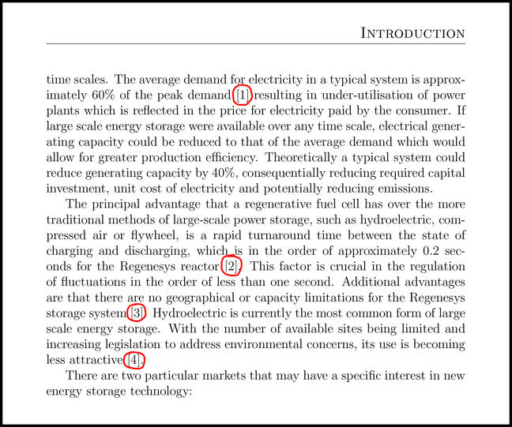

If someone else’s work has been cited, a section at the end of the report called “References” should be created. The References section is a list, linked to the citation in the body of the report, with each list item containing details of the original document.

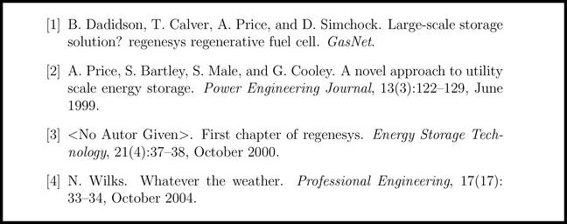

The reference acts as a pointer for the reader to locate the source of the original document (the primary source). Therefore the reference needs to include enough information to track it down uniquely. Whenever possible, you should read the primary source and use this as your reference. Secondary sources may contain mistakes and are often not peer-reviewed.

In the above example, the way in which the number is contained within square brackets and the way in which the information is written in the reference section is known as the **referencing style**. Each organisation will follow a specific referencing style and you should always check which style to follow.

Generally, there are considered to be two main styles of referencing. The first uses author surnames as the citation method and are listed alphabetically in the References section.

The second, as shown in the example above, uses sequential numbers as the citation and are listed in numerical order in the References section.

In either case, if a work is cited more than once in the body of a report, you don’t need to create a new item for it in the references list - just cite it again using the same pointer as the first mention.

For engineers, the most common styles are **Harvard** (author based) and **IEEE** (number based).

To help you get familiar with these referencing styles, let’s walk through an example of how to cite and reference a book using Harvard and IEEE.

## Referencing a book

You want to include some data in your report that you found in a book called ‘Solar Engineering of Thermal Processes’ by John A. Duffie and William A. Beckman.

### Using Harvard

Using the Harvard referencing style, this source is cited within the body of your report by giving the name of the author(s) followed by the date of publication:

**Citation**: Visible light, between 380nm and 780nm, comprises 47% of the total solar radiation and provides an average energy of 640W/m2 (Duffie and Beckman, 1980).

The following details about the publication are then given in the list of references at the end of the report:

**Author Surname, Initial(s). and Author Surname, Initial(s)., (Year). Title. Edition (if not first edition). Place of publication: Publisher.**

So this will look like:

**Reference**: Duffie, John A. and Beckman, William A. (1980). Solar Engineering of Thermal Processes. New York: Wiley-Interscience.

### Using IEEE

# Avoiding plagiarism

[**73 comments**](https://www.futurelearn.com/courses/technical-report-writing-for-engineers/6/steps/595448/comments)

**Plagiarism is using ideas or words from another person and submitting it as your own. It could include cutting and pasting text or images from a published work or could be graphs or drawings where you have not acknowledged the source.**

If you use someone else’s words, not only should it be referenced but also presented in quotation marks. For example:

“I think I can safely say that nobody understands quantum mechanics” (Feynman, 1965).

If you are not going to quote, but paraphrase instead, you need to find a way of saying the same thing without it looking ‘laundered’ (swapping out individual words). For example:

Quantum mechanics has been said to be so paradoxical that no-one really understands it, even eminent physicists (Feynman, 1965).

## Checking for plagiarism

When you submit work for marking at a university, your submission must be electronically readable (i.e. not a photograph of a handwritten note). This will be automatically checked by a software algorithm against published work and the work of other students at universities across the world.

The most common one you will hear about is called [TurnItIn](http://www.turnitinuk.com/). This software gives the marker a % of the content in the report which has been directly copied from other texts and where those texts are.

In many cases you will not be able to see your TurnItIn reports; they are only visible to the assessor.

There is no golden rule for how much text from other sources you can use, such as ‘30% is too high’. It all depends on the purpose and context of the report.

To be safe, you should ensure you make all efforts to identify work which is not yours and where you have collaborated in group work, make sure you identify the other members of the group.

As well as referencing sources that you find in your literature review, you must also acknowledge information that is given to you by your university, whether this is tutorials sheets, handouts, lecture notes or instructions for a lab practical. To do this, you would follow the standard format for referencing a chapter in a book.



For example, you want to include a diagram from your lab book. This is how you would reference it:

### Using Harvard

The University of Sheffield. (2017). Semiconductor Laboratory – Light Emitting Diode (LED). In Second Semester Practicals 2017 - Electrical and Electronic Engineering. Sheffield, Print and Design Solution. pp27-32.

### Using IEEE

[1] The University of Sheffield, “Semiconductor Laboratory – Light Emitting Diode (LED),” in Second Semester Practicals 2017 - Electrical and Electronic Engineering. Sheffield: Print and Design Solution 2017, pp27-32.

### Discussion

Why do you think plagiarism is a concern?

© The University of Sheffield

With the IEEE referencing style, each time you introduce an idea, thought or theory that belongs to another person, a reference number should be added and enclosed in square brackets e.g. [1], [2].

**Citation**: Visible light, between 380nm and 780nm, comprises 47% of the total solar radiation and provides an average energy of 640W/m2 [1].

If you are using the same reference more than once, it will keep the same number all the way through your report.

The citations are then listed by number (not alphabetically) in the reference list at the end of the report as follows:

**[No.] Initial(s). Surname and initial(s) Surname, Title, ed. (if not first edition) City of publisher, U.S. State if necessary, Country: Publisher, year.**

So this will look like:

**Reference**: [1] J. A. Duffie and W. A. Beckman. Solar Engineering of Thermal Processes. New York: Wiley-Interscience, 1980.

The University Library has detailed referencing guides for using the [Harvard](https://librarydevelopment.group.shef.ac.uk/referencing/harvard.html#collapseCitation) and [IEEE](http://librarydevelopment.group.shef.ac.uk/referencing/ieee.html#collapseCitation) referencing styles, including how to reference websites and other technical reports. We recommend you refer to these guides when you come to write your next report.

### Discussion

Have you used a referencing style before? Do you have any advice for referencing properly?

© The University of Sheffield

# Giving theoretical background to your project

[**41 comments**](https://www.futurelearn.com/courses/technical-report-writing-for-engineers/6/steps/595453/comments)

**When writing out the theory behind your project, it’s important to maintain a sense of balance. You don’t need to start by stating gravitational attraction or explaining that E=mc2, as there are certain general assumptions that you can make. However, you do need to define any equations or principles that are relevant to your project.**

### Identify your working area

To help you decide which principles and equations are relevant, think about the area you are working in. In the theoretical sense, this means the particular physics you are applying. This could be material science, classical mechanics, thermodynamics, electronics etc.

Having identified the working area, you can look within this area for the key theory and principles that apply for your experiment.

### Remember your audience

It’s important to keep your audience in mind and to consider what they will know so you can give the appropriate level of theoretical detail.

The introduction defines a common platform for the project and should give the reader enough detail about any background assumptions, terminology, and abbreviations.

### Describe the journey through the theory

Within the introduction, you should define the key parameter terms, either through diagrams or equations (or both). However, you must also explain the journey through the theory. It is not acceptable to list twenty equations in a row without any linking text.

Instead, the theory section often starts with the known level of knowledge and then links through to establish the necessary steps to complete the aim of the report.

### Explain your inputs, variables, and outputs

It should be clear from the theory section what the inputs, variables, and outputs are for the experiment. The initial outputs may well be in the form of raw data; therefore, it is important to show how that raw data will be processed in order to achieve a final result.

### Include any equations that you use in the results section

The theory section will be the basis of any analysis that will be undertaken in the results section of the report, therefore it should include any equations that will be used in the results section to understand or carry out the analysis. If you use equations that are not your own, it is important to reference them. You do not need to reference each one separately. For example, writing “The following derivation is adapted from [X]” is fine.

### Show examples of theoretical behaviour

The theory section is also a chance to show examples of theoretical behaviour typical to the project, for example, a stress-strain graph for a relevant material. This is so that when you come to discuss your results later in the report, you can show the reader if the result was as expected or differed from theory. It’s important to not just show this behaviour but to also explain the different parts of the behaviour and how they are identified on the graph.

© The University of Sheffield

# What is the difference between an aim and an objective?

[**58 comments**](https://www.futurelearn.com/courses/technical-report-writing-for-engineers/6/steps/595456/comments)

**Aims and objectives are both important in reports - they give a focus to the work presented.**

In this section, we’re going to show you how to write aims and objectives for your report. But before we get started, we want to find out - do you know the difference?

* What is the difference between an aim and an objective?
* Why do you need both in a report?
* Which is more important for understanding the project?
* Is there a rule on how many of each you should have?

© The University of Sheffield

# Aim and Objectives

[**39 comments**](https://www.futurelearn.com/courses/technical-report-writing-for-engineers/6/steps/595457/comments)

**A good introduction starts broad and becomes more focused, funneling down from the background of the project to the specifics of the research problem. It is here that you will articulate the aim and objectives of the project.**

The **aim** is your overall intention for the project. It is the reason why you are doing the research and signals where you hope to be by the end. The **objectives** are the specific steps you will take to get there.

When writing an aim, the convention is to use an infinitive verb – that is a to + action. This could be to measure, to investigate, to verify, to compare, to calculate…

A typical aim might read something like:

“The aim of this experiment was to determine how the elastic behaviour of a piece of bungee cord varied with applied load”.

The objectives are the specific steps you will take to achieve your aim. These are usually formatted as a numbered list to make it easy to see the main steps of the project.

Objectives for the above aim might be:

1. To apply increasing load to a piece of bungee cord and measure the deflection.
2. To examine the relationship between spring constant and applied load.
3. To calculate the natural frequency from spring constant values, at various loads.
4. To compare an experimental value of natural frequency with a predicted value.

The objectives should be specific and measurable. Each objective should build on the previous one and as such guide the reader through the structure of the report. This way the reader will have a clear idea about how the rest of the report fits together.

Be aware that the objectives are not all of the steps of the project. For example “investigate the context of the problem” is not an objective, it is a necessary step in all projects.

For most projects, you should intend to have a single aim that covers the overall conclusion you wish to make from the work. For the objectives, it might be worth breaking the project down into stages and to write an objective to describe each stage. For example, in a data driven project, there might be collection, processing and analysis phase.

The aim and objective should be put near the start of the report, within the introduction, as it will give clear direction to the reader and allow them to understand the context and theory presented given the overall aim. This is especially relevant to the objectives, in that the theory will be set out using those objectives.

© The University of Sheffield

# Where have we been? Where are we going?

[**77 comments**](https://www.futurelearn.com/courses/technical-report-writing-for-engineers/6/steps/595458/comments)

**This week, we have learned that an Introduction section is all about setting the scene and preparing the reader for what is to follow. This includes setting up the background concepts or theory required to appreciate the work as well as clearly articulating the aims and objectives.**

You have also developed two key skills this week that are often required to write introductory material:

* How to reference any previously published material that your work builds upon.
* How to properly embed equations into your document.

These skills can, of course, be applied in other parts of your report if required.

In a technical engineering report, there is a defined break between the background material that references other people’s work and the content for which you are taking ownership. This break normally occurs at the end of the introductory material, which could include a dedicated theory and/or literature review section.

Next week, we will look at how to start presenting the work that is yours. In a typical report, this is where you will explain what you did in your work to obtain your results. You’ll learn how to write a **Procedure section** and gain useful key skills to help with this, including how to embed figures and use the correct language.

### Discussion

How have you found this week of the course? Is there one key piece of advice that you will be taking away?

© The University of Sheffield

[**77 comments**](https://www.futurelearn.com/courses/technical-report-writing-for-engineers/6/steps/595458/comments)

Week3

# Where have we been? Where are we going?

[**77 comments**](https://www.futurelearn.com/courses/technical-report-writing-for-engineers/6/steps/595458/comments)

# The Procedure section

[**30 comments**](https://www.futurelearn.com/courses/technical-report-writing-for-engineers/6/steps/595459/comments)

**This week, we turn our attention to the Procedure section. This is where you will explain what you did in your work to obtain your results. This includes recording the steps that you followed and the equipment that you used.**

This section is sometimes called the ‘method’ section or, in scientific experiments, ‘materials and methods’. For example, a typical experiment in chemistry is the acid/base titration; the ‘materials’ part would involve listing the actual acid and base, as well as their concentrations; the ‘methods’ part would then make clear how the titration was carried out.

There are four aspects that should be included in the Procedure section:

1. A list of the equipment used and the types of measurement taken.
2. A chronological description of the steps you followed.
3. Any time considerations - for example, the time spent on a particular experimental step.
4. Any safety issues, especially if the reader is intending to repeat the experiment.

You can also include experimental diagrams to help your reader to understand the results and to repeat the experiment if necessary.

### What will the reader get out of this section?

There are two reasons why the reader will find this section useful:

1. The methods section will help the reader to make sense of the results. For example, a number in a table may represent a measurement; however, showing how this measurement was obtained and the range of equipment used gives more context to that number.
2. The reader may want to recreate your experiment, for example, to check your results for reproducibility. It should, therefore, contain enough detail to enable the reader to repeat the experiment if necessary - like sharing a recipe.

### What skills will I learn this week?

We’ll show you how to produce and embed useful engineering images into your report.

© The University of Sheffield

# So, what goes in the procedure section?

[**37 comments**](https://www.futurelearn.com/courses/technical-report-writing-for-engineers/6/steps/595469/comments)

**Information in the procedure section can be classified in one of two categories: information about the equipment and information about the experimental procedure.**

You might want to include a detailed description of your equipment before explaining the experimental procedure, or you may want to integrate this information. In some situations, it may be acceptable to write the experimental procedure as a numbered list. However, it is usual to write prose.

The general rule is that information should be presented in a logical order so that each statement follows on from the previous one; your reader should never have to look ahead to understand a statement.

The amount of information and detail you include will ultimately depend on the length of the report, and importantly, the extent to which you use experimental diagrams.

A well-labelled schematic diagram can help you to clearly explain the experiment whilst reducing the amount of text. Ideally, you should produce the diagram first, and then the procedure is easier to write.

Let’s start with the first category: equipment.

### What equipment did you use?

When it comes to describing your equipment, you may find it useful to consider the different types of equipment you used. All equipment falls into one of four categories:

1. Measurement equipment: The equipment you used to record your results. This could be in analogue form or a digital display.
2. Facilitation equipment: The core of any experiment. This is the ‘action’ equipment which allows ‘changes’ to be made to the system such as heaters, pumps and electrical power supplies.
3. Auxiliary equipment: This is equipment that is helpful, although not strictly necessary for the experiment. This might include stands, receptacles and working surfaces.
4. Composite equipment: This equipment combines the first and second categories, much of the proprietary teaching equipment that you use will fall into this category.

### Report the operating state of your equipment

You should note the operating state of equipment that has an on/off button. Such equipment can be considered to have one of the three following operating modes:

* Off (not yet switched on)
* At steady-state (on, and with all operating parameters staying constant with time)
* Unsteady-state (with one or more parameters changing with time)

**Example**: Consider a heater. Once the heat is switched on, it will take some time to reach steady-state, at which the temperature will be constant.

For some equipment, the time taken to reach steady-state is instantaneous, but for other equipment, the time is significant and should be made clear in the procedure. Also, at the end of the experiment, it should be made clear whether the equipment is switched off after the experiment or left operating.

### Listing the make and model

If the procedure can only be repeated using a particular piece of equipment, or the result would be different if a different manufacturer’s equipment were used, then the details of the make and model number of the equipment should be included. Otherwise, there is no need to include this information in the description.

There can be ethical considerations when describing the equipment you used. For example, mentioning equipment manufacturers by name could be regarded as inappropriate advertising, especially if there are alternative models.

This can be compounded by expressing opinions on the operational performance of the equipment - especially when the results are being discussed.

**Example**: The results from the voltmeter were questionable due to a poor standard of construction and an inability to obtain a stable reading, a feature available on models of similar equipment from alternative manufacturers.

To avoid controversy, be sure to express these types of opinions in dispassionate and objective language.

**Example**: The equipment was switched on and voltmeter readings were taken at regular intervals, although it was difficult to obtain a steady reading because of a continual drift. This could have been due to changing conditions or a manufacturing fault with the voltmeter.

On the next step, we’ll consider the level of detail you need to include when it comes to describing your equipment.

© The University of Sheffield

# Explaining the experimental procedure

[**33 comments**](https://www.futurelearn.com/courses/technical-report-writing-for-engineers/6/steps/595471/comments)

**As well as describing any equipment that you used, the procedure section should also describe the steps that you followed in your experiment.**

Here are some things that you should consider when describing the experimental procedure.

### Explain how the Risk Assessment impacted the experiment

For any experimental work, there will be an associated risk assessment (RA) form and, where chemicals are involved, a Control of Substances Hazardous to Health (COSHH) form. The first stage of the experimental procedure is to report the findings from the RA and how they have impacted on the experimental procedure.

### List tasks in the order that they happen

The experimental procedure can be considered to consist of a number of tasks. All tasks can be divided into one of the following four categories:

1. Measurement (recording data manually or operation of a data acquisition system).
2. Operational (changing system parameters, for example, flow, temperature, pressure, composition etc).
3. Manual (for example, moving or cleaning equipment).
4. Construction (typically, assembling or disassembling equipment).

The list of tasks can either be carried out in series (one after the other) or in parallel (tasks occurring at the same time). Your procedure section should state the tasks in the order in which they happen. This will make it clear whether the tasks are in series or parallel.

### Give timings

The procedure should also give any time considerations. For example, if operating from cold, the time taken for the equipment to reach steady-state should be stated if this is a reasonable part of the overall experimental time. In the case of repeat measurements (for example to test reproducibility), the number of repeat experiments should be made clear.

### Record group size

Information on the group size will be invaluable for any reader who is considering repeating the experiment. Try to consider what might be the minimum and maximum number of people required to operate the equipment. Don’t be confused by the number in your actual group - this is often determined by timetable requirements. This type of critical analysis - where you analyse what is currently taking place - is a transferable skill that is useful in management situations.

### Report quantities in their units of measurement

If a length is measured in furlongs, then it should be reported in furlongs. Any quantities should be reported in the units they were measured in. They should NOT be converted to SI units (an international set of units derived from the French: Système international d’unités). You will do this in the Results section of the report.

**Example**: Small volumes are typically measured in ml. If they are required in the SI units of m3, the numbers would be multiplied by the appropriate conversion factor in the Results section of the report.

### Explain what happens next

The experimental procedure should not end with the last measurement. There are two further considerations:

1. What is required to happen for the equipment to be used for future sessions.
2. Any disposal issues that should be considered (more common in chemical engineering experiments).

Try not to simply accept that the procedure is perfect - consider whether it might be improved. This provides an opportunity to show the person reading your report that you have thought critically about the experiment.

**Example**: Your experiment involved mixing two components to form a mixture. The mixture has limited use after the experiment and you spend time disposing of it properly. Therefore you report that less mixture should be produced in future experiments to reduce both waste and experimental time.

Now that we have covered what goes in this section, let’s turn our attention to how it should be written. Your procedure section should be presented in a specific way - using what is known as the passive voice so that the reader can focus on the experimental method. In the next section, we’ll look at the language conventions you should follow when writing your procedure.

© The University of Sheffield

# Using the passive voice

[**41 comments**](https://www.futurelearn.com/courses/technical-report-writing-for-engineers/6/steps/595460/comments)

**When it comes to writing your procedure, it’s important to remember that you are writing a technical report. In other words, you are reporting what happened in the experiment. But, unlike a journalist reporting a political scandal in a newspaper, engineers are not interested in who did the work - they are only interested in the experiment itself, in other words: the methods that were used.**

The reader wants to focus on the experimental (or numerical) method, so the writer (i.e. you!) has to become invisible. This means using the **passive voice**.

### Active vs Passive voice

In English, we can use the Active or Passive voice when communicating.

In technical reports, we often use the Past Passive because we are describing actions that have been completed. Other verb tenses and voices can also be used, but Past Passive is the most common one in the methods section.

So here’s a brief explanation:

The Active voice tells us **who** carried out an action:

***John*** ate my chocolate.

If I want to know who ate my chocolate, I can ask: “Who ate my chocolate?” and I get the answer, “John”. If John is in the room (and he is honest!), he would say “Me”. So I know **who** ate my chocolate.

The Past Passive voice focuses on the finished action, not the person who did it.

The chocolate ***was eaten***.

This example does not tell me who ate the chocolate.

When writing the Past Passive, you need to be careful about using the correct singular or plural verb:

For example:

* One apple was eaten.
* Two apples were eaten.

In everyday life, we’re usually quite interested in who did what. Technical Writing is different.

If you carried out an experiment, and you’re writing the methods section, the reader already knows that it was you who did it, so it is unnecessary to keep telling them (e.g. “First I prepared the equipment. Following this, I calibrated the device”).

Even when several people work together to do an experiment, the reader isn’t usually interested in who did what.

The reader just wants to know what happened (and is not interested in you).

© The University of Sheffield

# Language do's and don'ts

[**57 comments**](https://www.futurelearn.com/courses/technical-report-writing-for-engineers/6/steps/595461/comments)

**There are some specific language conventions that your procedure section should follow. In this step, we’ll share our language ‘Do’s and Don’ts’ to help keep you on track:**

## DO …

* Remember who the reader is.
* Write the methods section in chronological order (in the same order that you carried out the experiment).
* Write the methods section in paragraphs and connect your sentences.
* Use the Passive Voice (usually Past Passive, e.g. “the measuring device was calibrated”).
* Use sequence words to explain the order of what happened e.g ***“First***, the measuring device was calibrated and checked and the guillotine cleaned with white spirit. ***Next***, the specimens were measured. ***Following this***, …”.
* Use words and phrases like ‘to’, ‘so as to’ and ‘in order to’ to explain the purpose of a stage or step of an experiment e.g. “The guillotine was cleaned with white spirit in order to ensure a clean cut and to prevent contamination.”
* Use full forms rather than contractions e.g. ‘do not’, ‘will not’, ‘cannot’.
* Use specific vocabulary, e.g. ‘item’, ‘equipment’, ‘object’, ‘material’, ‘sample’.

### DON’T…

* Copy and paste the instructions from the Lab or Experimental brief (e.g. ‘Calibrate the measuring device’)
* Just list your actions.
* Use ‘I’ or ‘We.’
* Use colloquial sequence words like ‘after that’ or ‘so in the end’.
* Use ‘Then’ at the beginning of a sentence. Place it like this: “Load was then applied”.
* Use vague words like ‘stuff’, ‘things’.
* Use phrasal verbs, idioms or metaphors such as “the signal was wiped out”.

### Discussion

What are your tips for getting the language right?

### DOWNLOADS

You can download these tips from the bottom of this page.

© The University of Sheffield

# Language practice task: writing a methods section

[**73 comments**](https://www.futurelearn.com/courses/technical-report-writing-for-engineers/6/steps/595462/comments)

**Below are some instructions for an experiment to measure wind tunnel drag. Imagine you have carried out this experiment and followed all the instructions. Now you have to write your own methods section.**

Use the comments to have a go. We have given the first two steps as an example. Remember to use sequence words and the passive voice!

### A. Procedure:

1. **Note** the aerodynamic shape and dimension in the experimental record, and the number of the wind tunnel for the experiment.
2. **Ensure** the wind tunnel is off and no air is passing through the working section.
3. **Zero** the velocity and drag readings.
4. **Input** a small value of “Fan speed” and **turn** the fan **on**.
5. Once a steady state has been reached, **record** the velocity and drag (as well as uncertainty) from the software.
6. **Repeat** step 5 with increased values of fan speed, to obtain a suitable number of readings.
7. **Perform** the same experiment with alternative aerodynamic models.

### B. Experimental Method

First, the aerodynamic shape, dimension and wind tunnel number were noted. Following this, the wind tunnel was checked to ensure that it was off and no air was passing through the working section. …

© The University of Sheffield

# Where should you use figures?

[**61 comments**](https://www.futurelearn.com/courses/technical-report-writing-for-engineers/6/steps/595463/comments)

**We know that pictures tell a thousand words, however in a technical report we can’t create a cartoon strip of every step.**

* Which sections of a report need figures?
* What do you think makes a good figure?
* How much should you explain the figures and how much should you let them speak for themselves?
* Is there a correct number of figures to include? What does it depend on?

© The University of Sheffield

# Around the figure

[**43 comments**](https://www.futurelearn.com/courses/technical-report-writing-for-engineers/6/steps/595465/comments)

**So you’ve just spent hours creating the perfect figure to include in your report. To make sure it gets the impact it deserves, you need to make sure it’s labelled and referenced properly.**

When adding a figure, there are three simple things you need to check:

1. Every figure is numbered consistently.
2. The figure is referred to in the text (preferably before the figure is shown).
3. The figure has a caption that describes what it is.

### 1. Every figure is numbered consistently.

Let’s start with numbering. In short reports this should be Figure 1, Figure 2 etc. in longer reports you may want to include the chapter number i.e Figure 1.1, Figure 1.2. Whichever style, it’s important to ensure there is a unique identifier for each figure which you can then refer to in the text i.e. “as shown in Figure 1.2”.

### 2. The figure is referred to in the text.

Figures should generally go after they have been referred to in the report, and as close to this as possible. Having to flick onwards or backwards to look at figures can be disruptive to the reader so try to keep that to a minimum.

Every figure should be included for a reason. A common mistake when writing a report is to include figures that you consider interesting, but are not discussed in the text. A useful check to perform when you have written a report is to ensure that all the figures included are referenced in the text at some point. Using figure numbers helps with this process.

Figures are meant to help the reader to understand the project and its significance. With this in mind, it’s important that the reference to a figure is not just “shown in figure 1.2”. Depending on what the figure is, the text must draw the reader to the important points.

Do not expect the reader to interpret figures, instead, you should give a clear explanation which is supported by the figure. Try and make sure the reader knows exactly what they are looking at, this is particularly important when using figures to show results (which we will cover in more detail next week).

### 3. The figure has a caption that describes what it is.

Captions should be simple but informative. It is important to strike the balance between a clear title for the figure and the supporting discussion which is within the text.

Let’s look at some example captions for the following figure.

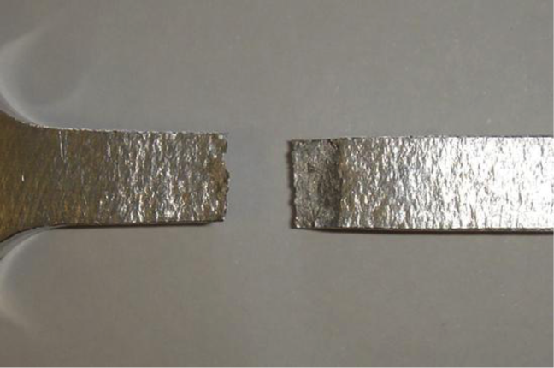

Figure 1. A broken specimen.

This caption tells us pretty much nothing. This is an example of a poor caption.

Figure 1. The fracture surface of an aluminium sample after tensile loading.

This tells us which specimen it is (aluminium) and also what we are looking at (fracture surface). This is a much better caption.

Figure 1. Fractured sample made from an aluminium alloy (AA2024-T351) subjected to quasi-static tensile loading. Fracture occurs after localised necking in the gauge section of the sample.

This caption also tells us about the circumstances of the fracture. If you were going to put several specimen pictures in together, then giving the stress at fracture within the caption could aid the reader’s comparison between the samples.

How much information to include in the caption is up to you as the writer. What is important is that there is enough information so that if the reader only looked at the figures, they would still understand what they are looking at.

© The University of Sheffield

# Charpy impact test: how would you write a procedure section?

[**57 comments**](https://www.futurelearn.com/courses/technical-report-writing-for-engineers/6/steps/595472/comments)

**This week, we have looked at the information that goes in a procedure section, the typical language conventions that this section should follow and the importance of a good experimental figure. Now let’s consider how we would apply this to describe a real engineering experiment.**

In this video, we’ll revisit the Charpy impact experiment. As you watch the video, make a note of the information you would want to include in a procedure section.

* What information from the video would you be sure to include?
* Is there anything in the video that wouldn’t be relevant?
* What information do you think is missing?
* What figures might you want to include?

Share your thoughts with your fellow learners using the comments.

# Charpy impact test: an example procedure section

[**49 comments**](https://www.futurelearn.com/courses/technical-report-writing-for-engineers/6/steps/595473/comments)

**We have written an example procedure based on the Charpy impact experiment. In this video, Andrew will read this procedure section as we replay the experiment.**

You might like to download the procedure and read along as you watch the video. You’ll find this under ‘DOWNLOADS’ at the bottom of the page.

Compare your notes from the previous step with this example: what do they have in common? What is different?

© The University of Sheffield

# Be the marker: Procedure section

[**63 comments**](https://www.futurelearn.com/courses/technical-report-writing-for-engineers/6/steps/595467/comments)

**This week, you have learned what is good practice for putting together a Procedure section. In this discussion, we’d want to put this knowledge to the test.**

Below is an example procedure section. We’d like you to read through this example and comment on the following:

* What is good about it?
* What is bad?
* How might the section be improved?

## 3. Procedure

### Diagram

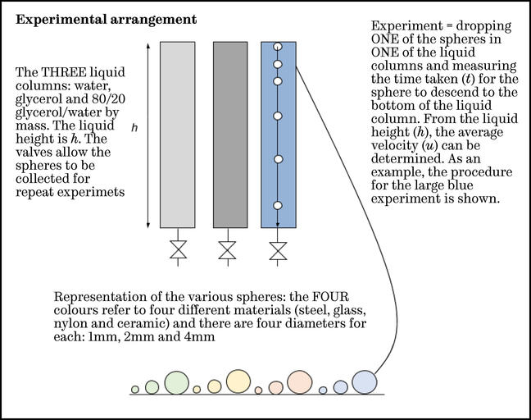

### Experimental procedure

A single experiment consists of calculating the average velocity of a particular sphere in a particular liquid. A sphere is dropped onto the upper surface of the liquid and, due to gravity, it settles to the bottom. There were two fixed points on the columns. Care was taken to avoid spills and to ensure the ball was placed at the centre of the column to minimise wall effects. The distance between these points will be determined after the experiment is completed. We used a stopwatch (precise to 0.01 seconds) to time how long it takes for the ball to travel between these two points. By dividing the distance travelled by the time taken to travel the average velocity of the ball can be determined.

The first set of experiments involves the water column and a selection of the spheres. The second set of experiments involves the glycerol column and just the smallest spheres. For those experiments with fast transit times, repeat experiments were carried out. The detailed procedure (actual number and order of experiments) is listed in the Results section.

### Equipment list

As shown above, there are three columns, each with a diameter of 10 cm. One column is filled with water, one with glycerol and the third is filled with a mixture of water and glycerol. There is a range of both sphere size and sphere material available for the experiment. There is a trap at the base of each column that allows the spheres to be removed conveniently without significant loss of liquid.

© The University of Sheffield

# Where have we been? Where are we going?

[**54 comments**](https://www.futurelearn.com/courses/technical-report-writing-for-engineers/6/steps/595468/comments)

**This week, we have learned how to write an effective Procedure section which includes enough detail to enable someone to repeat your experiment.**

You now know how to describe the equipment you used so that someone can do the same experiment in a different laboratory with similar equipment. You also know how to describe the steps you followed, including clear instructions with timings and quantities, as well as any ethical or risk elements that should be kept in mind when setting up and conducting the work.

You have developed two key skills this week that will be useful throughout your report: how to present drawings and photographs effectively and how to refer to them in the text.

By understanding what you did, your reader is now better placed to understand what you actually got out of the work. You will report this in the next section, the **Results**.

Next week, we’ll show you how to put together a Results section including how to display and comment on your results using graphs and tables.

### Discussion

How have you found this week of the course? What key piece of advice would you share with other engineers?

© The University of Sheffield

Week 4

# Technical report writing and your career

[**38 comments**](https://www.futurelearn.com/courses/technical-report-writing-for-engineers/6/steps/595474/comments)

**As we’re just past the halfway mark in the course, we thought now would be a good time to check back in with our expert engineers for some words of encouragement that will inspire you to keep going.**

In this video, we ask a range of successful engineers from across the industry to explain why good report writing is important for your career.

© The University of Sheffield

# The Results section

[**56 comments**](https://www.futurelearn.com/courses/technical-report-writing-for-engineers/6/steps/595475/comments)

**This week our focus is on the Results section. This is where you communicate the values you’ve measured, the readings you’ve taken and the observations you’ve made during your experiment. In the earlier sections of your report, you will have informed the reader about why and how you did the work. This section reports what you got out of it.**

Everything in the Results section is factual; these are the things that you have obtained from your experimental or modeling work. You’ll use graphs or other graphics to help the reader understand any important features or trends in your data.

This week, we’ll show you how to clearly communicate what your experiment produced.

You’ll learn how to:

* display data effectively in graphs, tables, and figures
* report a number of significant figures
* write detailed descriptions that will enable the reader to understand the features in your results

### What will the reader get out of this section?

Your results should be complete enough to allow the reader to understand what you obtained, without having to do the same work.

If they wanted to carry the work on, they should be able to take what you have produced and extend it.

A good description of the results will also prepare the reader for the next section - the Discussion. In the Discussion, you’ll put your results into context and use conjecture and comparison, alongside information from the Introduction to convey your understanding of the results and their meaning.

### What skills will I learn this week?

You’ll learn how to produce proper engineering graphs and tables (as well as how to avoid making common mistakes).

Let’s start with what goes in the results section (and what information is better presented elsewhere).

### Discussion

Why do you think the results should have their own section?

© The University of Sheffield

# What goes in? What goes out?

[**48 comments**](https://www.futurelearn.com/courses/technical-report-writing-for-engineers/6/steps/595476/comments)

**The results section is where you present what you got from your experiment. It has very clear requirements. In this step, we’ll explain the information you should include in this section and the information that is better presented elsewhere.**

### What goes in?

You should report the results of your experiment, both in terms of raw and processed data (which we will look at on the next step). You can also report on errors in the work, but only so that you can account for the features and scatter that will be present in the results.

The best results (indeed the best reports) tell a clear story. When you have all your data, you should think about how you are going to group, organise and display your results in a logical order. This may not be the order that you obtained them in. For example, it might be best to organise sets of tests in order of ascending magnitude, or to group them in terms of geometry with magnitude varying with each set.

Including reams of very similar data will also make your results section tedious to the reader. It is often best to include a few example results and some summary tables or figures and put the rest into appendices. We’ll look at appendices in more detail in Week 6.

The results section contains more than just the bare results. It also puts them into context and helps the reader to interpret them. The writing around the figures and tables serves to introduce what they are and what conditions you obtained them under, as well as guiding the reader to understand the features in your results. It is best to include at least one sentence under the final table or figure to describe it. You will want to use phrases such as:

* “It can be seen that…”
* “There is a linear relationship between…”
* “The trend is unclear at this point…”
* “When the results are non-dimensionalised, the curves collapse to show a single trend…”

### What goes out?

The **Discussion** section of the report is there to put the results into context and describe their limitations. It is the only part of the report where you can use conjecture. Your writing in the Results section should not describe what the results mean. So if you are using phrases such as:

* “This could be due to…”
* “This supports the view of previous researchers…”
* “This uncertainty might arise for the following reasons….”
* “All of the sets of results indicate…”

…it is best to put this information into the Discussion instead.

It is often acceptable, particularly in short reports, to combine the Results and Discussion into a single section.

### Discussion

Why do you think the analysis of errors in results should not feature in the results section?

© The University of Sheffield

# Raw vs processed data

[**48 comments**](https://www.futurelearn.com/courses/technical-report-writing-for-engineers/6/steps/595477/comments)

**When you come to report results from an experiment, you will want to tell the reader about what you obtained from the experiment. This takes two forms; the readings that you actually recorded, known as raw data, and what they showed once you’ve turned these into a form which helps the reader to interpret the results, which is processed data.**

For most experiments, you will want to include both in your report, but it is important that you think about what you are presenting and the best form to put it in.

### Raw data

Raw data is the data that comes straight off the experiment. It might be scaled, or filtered, but it is the first data that can be recorded.

Some examples of raw data are:

* Pressure in mm water to measure flow with an orifice plate.
* Signals per second for rotating machinery.
* A voltage signal from a microphone with each data point.

It is vital that raw data is recorded and preserved. For data taken in a laboratory, a **lab book** is a vital tool in this. This is because it may need to be reprocessed at a later date or shared with another researcher.

### Processed data

Processed data is the raw data, dealt with so it can be used more easily, or displayed to show a result or feature.

Let’s look again at the examples of raw data alongside examples of how this data might be processed.

| **Raw data** | **Processed data** |
| --- | --- |
| Pressure in mm water to measure flow with an orifice plate | Convert the height into a pressure in Pa by multiplying by 9.81, then use the equation in ISO 5167 to calculate flow rate in m3s-1. |
| Signals per second for rotating machinery | Convert this into radians per second, then multiply by the radius of the rotating part to obtain the surface speed of the part. |
| A voltage signal from a microphone with each data point. | Filter to remove noise. Perform a Fast Fourrier Transform (FFT) on it to extract the main harmonics, output these to display and process further. |

### Do I need to include raw data in my report?

It is a matter of choice whether to report raw data in the results section of a report. The method used for scaling and processing of raw data will usually be described in the **Method** section of a report. If so, it is less important that it is put into the report.

You may want to include a plot of the raw data so your reader can see the spread of results that were obtained. If there are more than about 10 values, it is often best practice to put the raw data values into an **Appendix** (we’ll look at appendices in more detail in the final week of the course).

Processed data is usually much more useful to the researcher, as it is typically in commonly used units and is easier to analyse. It will also be easier to compare this to other researchers’ work (typically in the discussion).

So when you deal with data, think about what type it is, what you are going to do with it, and how and where you are going report it.

### Discussion

How do you think you should record data so it can be used to produce an effective technical report?

© The University of Sheffield

# Units of measurement

[**28 comments**](https://www.futurelearn.com/courses/technical-report-writing-for-engineers/6/steps/595484/comments)

**Engineering is concerned with quantities, not numbers in isolation. As an engineer, you always consider quantities expressed as a number and a unit together. For example, a length is a quantity and can be expressed as a number of metres, where the unit is indicated by the word “metres”.**

A length of about one metre can be defined as a multiple of many different units:

* 1.9 cubit
* 39.370 inch
* 52.5 unglie
* 1 650 763.73 wavelengths of the orange-red emission line in the electromagnetic spectrum of the krypton-86 atom in a vacuum

Although any one of these units may be correct, they may not always be understood by your reader. To ensure that quantities are understood throughout the world, an international set of units, SI (from the French: Système international d’unités), has been defined.

These are the most familiar units, for example metres (m), Volts (V) or Specific Entropy (J kg-1 K-1). There are [seven base SI units](https://www.npl.co.uk/getmedia/b097a52d-8043-46e0-aa0c-14e64b56d95b/NPL-Schools-poster-_-7-SI-BASE-UNITS-v12-HR-NC.pdf) and [any number of derived ones](https://physics.nist.gov/cuu/Units/units.html). It’s vital that you use these whenever a value is reported.

Variables need to have their units defined at least once either in the nomenclature (as we saw in [Week 2](https://www.futurelearn.com/courses/technical-report-writing-for-engineers/6/todo/56109)) or in the text where they are first used.

Whenever you report a value, you should include its units. There are two ways of writing units: using an exponent and using a slash sign. Both are acceptable, but you must be consistent throughout your report. This is particularly important if you are collaborating with others on a report.

### Here are some examples of SI Units:

| **Unit** | **In words** | **Using an exponent** | **Using a slash (division sign)** |
| --- | --- | --- | --- |
| Specific entropy | Joules per kilogramme per Kelvin | Jkg-1K-1 | J/(kg K) |
| Acceleration | Metres per second squared | ms-2 | m/s2 |
| Viscosity | Pascal seconds or Newton metres per second | Pa.s or Nms-1 | Pa.s or Nm/s |

Table 1: Examples of some SI units.

Note that unit symbols remain unaltered in the plural, so there should be no confusion between pascal seconds, written as Pas, and the plural of pascals which is just Pa. However, it is a good idea to put a dot or space between the “Pa” and the “s” (Pa.s, or Pa s) to be clear.

Units can be modified by prefixing a letter which indicates that it is multiplied by a power of 10. For example, the amount of power produced from a large power station is 2 trillion (109) Joules per second, but we usually report this as 2GW.

### The most common prefixes are shown below:

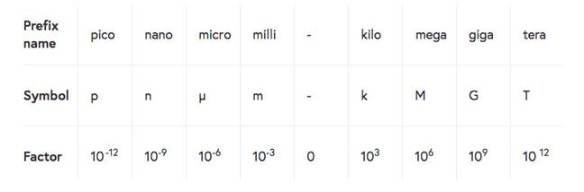

Table 2: Prefixes for SI units.

Note that the prefix indicating multiply by 1000 is a lowercase k. The uppercase K is the unit symbol for the kelvin, so 1 Kg denotes one kelvin gram, which is different to 1 kg, a kilogram.

### DOWNLOADS

You can download these tables below to remind yourself how to report units of measurement when you come to write your next report.

© The University of Sheffield

# Significant figures

[**36 comments**](https://www.futurelearn.com/courses/technical-report-writing-for-engineers/6/steps/595485/comments)

**It would be easy to report all numbers to the accuracy that your device or computer displays, but this is not necessarily the appropriate number to include in your report. It’s perfectly acceptable to do calculations using any number of digits. However, they should be reported to the number of significant figures that the data supports. The number of significant figures indicates the precision of the value.**

The number of significant figures (sf) that a number is quoted to is determined by counting digits from the largest (leftmost) nonzero digit to the end of the number. For example, π written to 6 sf would be 3.14159. The number of sf indicates the accuracy of the value.

This table shows some numbers and their reporting to various significant figures. Note that you should use trailing zeroes (shown in bold) if needed to report to the appropriate number of significant figures.

| **Distance (m)** | **1 sf** | **2 sf** | **3 sf** | **4 sf** |
| --- | --- | --- | --- | --- |
| 32.9798563 | 0.03 km | 33 m | 33.**0** m | 32.98 m |
| 0.0001348546 | 0.1 mm | 0.13 mm | 0.135 mm or 135 µm | 0.1349 mm or 134.9 µm |
| 1384.9328 | 1 km | 1.4 km | 1.38 km | 1385 m or 1.385 km |
| 3.04579839×106 | 3 Mm | 3.**0** Mm | 3.05 Mm | 3.046 Mm or 3046 km |

Table 1: Reporting distances to a variety of significant figures.

When reporting to significant figures, be sure to choose the size of your unit, [using an appropriate prefix](https://www.futurelearn.com/courses/technical-report-writing-for-engineers/6/steps/595484#table_anchor_location), so that the accuracy of the number is clear. For example, if you were to report 32.9798563m to 1 sf as 30m, your reader could think that the number is correct to 2 sf (between 29.5m and 30.5m) as indicated by the trailing zero.

Also be sure to use a unit that your audience will understand. For example, if your reader would not understand Mm you could use km instead (3.04579839×106 m reported to 1sf is 3×103 km).

### Let’s look at some examples…

You are measuring the length of a 25 mm-long rod with a ruler. You can read a ruler (if you’re careful) in fractions of a millimeter, so reporting the length as 25.0 mm is reasonable, but 25.00 mm implies that you are able to read the ruler to the nearest 0.01 mm and reporting the length as 25 mm would imply that it could be between 24.5 and 25.5 mm. In this case, 3 sf are appropriate.

If you now measure the rod’s 2.6 mm diameter then this should be reported as 2.6 mm (assuming you have used your ruler correctly). Now you are only able to report to 2 sf.

The circumference of the rod is π times the diameter. How should this be reported?

2.6π = 8.168141, but if you report the value using this number, it implies that the diameter was known to about 7 sf. The circumference should be reported as 8.2 mm; this uses the same number of significant figures as the diameter.

Note that the range of possible circumferences for a diameter reported as 2.6 mm is between 2.55π mm = 8.0 mm and 2.65π mm = 8.3 mm, so reporting a circumference of 8.2 mm implies more precision in your measurement than you started with; if this is important then you could write the answer as 8.2 ± 0.2 mm.

### Remember the rules for rounding numbers

In order to report to an appropriate amount of significant figures, you may need to round your results. The methods for rounding numbers should be familiar to all students studying engineering, but here’s a quick reminder.

The rule for rounding to the nearest positive whole number is: if the decimal part is > 0.5, round up; if it is < 0.5 round down; if it is exactly 0.5, then round toward the nearest even number.1 The round towards even rule is to avoid always rounding upward numbers ending in 5. This avoids producing a higher average from a data set than would be expected.

This rule is easily generalised for rounding to different numbers of decimal places.

Here are some examples:

* Rounding 2.135 to 2 dp produces 2.14 (i.e. an even last digit)
* Rounding 2.143 to 2 dp produces 2.14
* Rounding 2.145 to 2 dp produces 2.14 (i.e. an even last digit)
* Rounding 2.1451 to 2 dp produces 2.15

### Discussion

Should you do the error analysis before you know how many sf to use in your results?

[1] Recommended in BS 2846-1:1991 “Guide to statistical interpretation of data. Routine analysis of quantitative data”.

© The University of Sheffield

# Types of graph (and when to use them)

[**45 comments**](https://www.futurelearn.com/courses/technical-report-writing-for-engineers/6/steps/595478/comments)

**You have results from your experiment and want to present them so that the reader understands what you have found. It is said that a picture is worth a thousand words, so it’s worth taking some time to get the correct information well presented.**

There are three main types of graph that you could use in your report:

* Bar chart
* Pie chart
* Scatter plot

The type of graph you use will depend on your data and on what you want your reader to notice.

### Let’s look at an example.

Imagine you are measuring average flow through four pipes of different roughness.

| **Pipe number** | **Roughness (RA)/mm** | **Flow (l/min)** |
| --- | --- | --- |
| 1 | 0.02 | 7.2 |
| 2 | 0.25 | 4.3 |
| 3 | 1.0 | 2.7 |
| 4 | 3 | 1.3 |

Table 1: Average flow measured through four pipes of different roughness.

|  |  |
| --- | --- |
| If the experiment was to compare the flow through the pipes, then a **bar chart** would be appropriate. Bar charts are used to compare results for a set of different conditions. They can be horizontal too which is useful if labels are too long or there are more than about 6 data points. | **Bar chart** A bar chart showing the average flow through four pipes of different roughness. The y-axis shows flow in litres per minute running from zero to eight, and the x-axis shows the pipe numbers from one to four. The chart shows a descending level of effectiveness from the pipes, with pipe 1 measuring 7.2 litres per minute, pipe 2 to measuring 4.3 litres per minute, pipe 3 measuring 2.7 litres per minute and pipe 4 measuring 1.3 litres per minute. |
| **Pie chart** A pie chart showing the portion of flow through four pipes connected in parallel between a high and low pressure reservoir. Pipe 1 represents the largest segment with 47%. Pipe 2 has 28%, then pipe 3 with 17% and finally pipe 4 with 8%. | If the experiment was to determine the proportion of flow through four pipes connected in parallel between a high and a low pressure reservoir, then a **pie chart** would be appropriate. Pie charts are used to explain how a total is broken down and are particularly good for illustrating fractions. They are rarely used in technical reports of laboratory or experimental work as there is no simple way to use a pie chart to illustrate multiple readings. |
| If the experiment was to explore relationships between pipe roughness and flow rate, then a **scatter (line) plot** would be appropriate. Scatter plots are used to show the relationship between two variables or the development of a variable over time. This is the most common type of plot for laboratory or experimental work. | **Scatter chart** A scatter chart showing the relationships between pipe roughness and flow rate. The y-axis is labelled flow in litres per minute and runs from zero to eight, the x-axis is labelled roughness showing roughness average per millimetre running from zero to four. The points plotted on the scatter chart show a decrease in flow rate as the roughness average per millimetre increases. |

If the experiment was to determine which pipe had the largest flow then it may not be appropriate to include any graph. You could include the **table**, perhaps highlighting pipe 1. Tables are ways of displaying data where the actual numbers are important. We’ll come back to tables later this week.

Let’s look at some different data scenarios and the types of graphs you could choose to present this information.

### Comparing results

You have carried out an experiment for a set of different conditions and want to compare the results. Each condition can be represented by a column in a bar chart. However, if you have more than one result for each condition, a bar alone would not be sufficient to indicate the range of results.

Instead, you can use “error bars” - these look like capital I’s, showing the spread of your results for the condition. These do not indicate errors, but rather the overall distribution of the data. This could be the range, the standard deviation or for example, the 95% confidence level. You would describe what they referred to in the text.

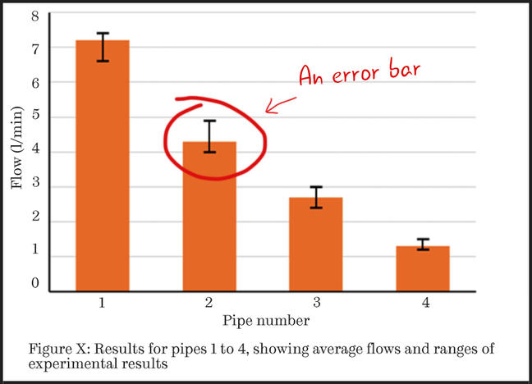 Figure 1: This bar chart features error bars to demonstrate the range of results obtained.

### Showing relationships between results

If you want to show the relationship between variables and have multiple results, then you could plot all of the results on a scatter graph and include a trend-line to illustrate the observed trend.

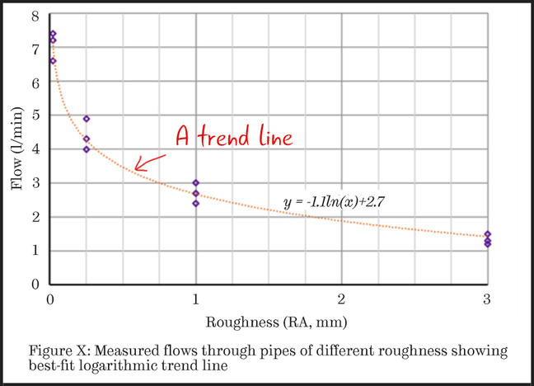 Figure 2: This scatter chart features a trend-line to illustrate the observed trend.

Figure 2 has the usual linear axes, but if you wanted to emphasise a non-linear trend it may be better to use a logarithmic scale on one or both axes.

On a base 10 logarithmic scale, each value on the x-axis is the previous value multiplied by some number. For example, in Figure 3 below, the values on the horizontal axis are 0.01, then 0.1, 1 and finally 10.

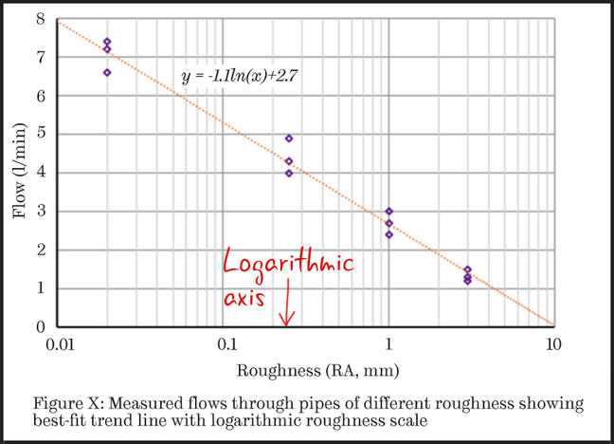

Figure 3: This scatter chart demonstrates that the data is consistent with the ‘expected’ type of equation (presented as the equation of the trend-line).

Logarithmic scales are harder for your readers to interpret than linear ones so you need to have a good reason for changing the scale. You will usually use them if you want to demonstrate how well your data fits a theoretical nonlinear equation.

For example, in Figure 3, the equation of the trendline is y = -1.1ln(x) + 2.7, in which ln(x) indicates the natural logarithm of x.

By using a logarithmic scale, the reader is able to see how well the data agrees with this equation. This could support later discussions in the report about the level of roughness at which flow would become negligible.

### In summary…

If you want to illustrate a:

* comparison between cases, **use a bar chart**.
* relationship between variables, **use a scatter plot**.
* division of a total into different components, **use a pie chart**.

If you have multiple values for a set of experimental conditions (more than about 10) then you may wish your reader to understand how they are distributed. Showing a **distribution of results** is only necessary if you have many results for a set of experimental conditions.

We’ll look at distributions in more detail on the next step.

### Discussion

Consider the experiment reported in Figure 2 (above). How would you present the flow measurements if you measured the pipe roughness and found it was different at different positions through the pipes?

### SEE ALSO

We’ve included some helpful links for creating graphs below.

© The University of Sheffield

# Showing distributions of results

[**26 comments**](https://www.futurelearn.com/courses/technical-report-writing-for-engineers/6/steps/595479/comments)

**If you have multiple values for a set of experimental conditions (more than about 10) then you may wish your reader to understand how they are distributed. The number of points and how you want to show them will affect which type of plot you choose.**

### Let’s look at an example.

We’ll return to the flow experiment from the previous step. Assume that you have 1000 data values for the flow through pipe 1 (not unusual if you use a data logger).

You could illustrate these on a scatter plot as shown below. This would show the chaotic nature of the readings, but discerning features of the distribution is difficult.

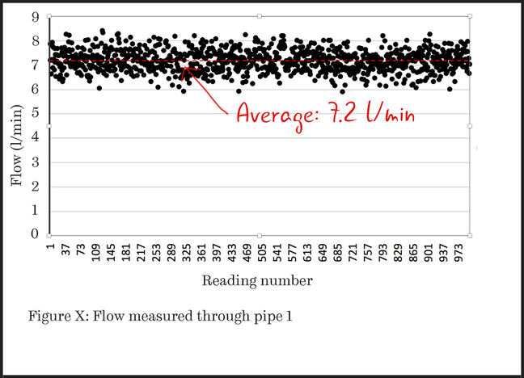 Figure 1: A scatter plot with 1000 data values.

### Rank the data points

Simply by ordering the data points, the reader can more clearly see what the distribution of the readings is. If the data plots as a straight line, then the data is uniformly distributed throughout its range. However, this is unusual.

The plot of Figure 2 is more typical, with curved ends. You can imagine the horizontal axis being stretched until the line is straight. Once this is done, the amount of stretching indicates the statistical distribution that best describes the data, with associated parameters being given by the properties of the straight line.

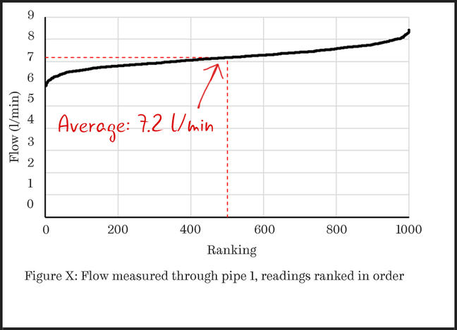

Figure 2: In this scatter plot, the data points have been ranked in order so that the distribution of the readings is clear.

### Categorise the data into bins

You could also display the distribution as a **histogram**. This requires that you analyse the data, counting how many results fall into separate “bins”. In this example, these are the ranges of flow rates shown on the horizontal axis.

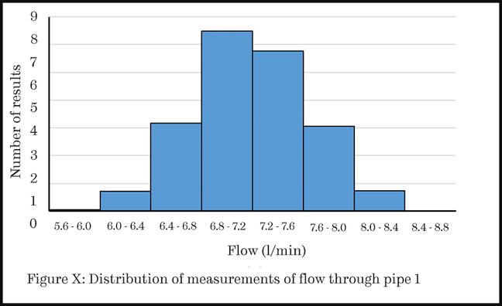 Figure 3: In this histogram, the data has been categorised into ‘bins’.

Using a histogram is appropriate if you have chosen a few bins (notice that with only eight bins the labels on the horizontal axis are already quite difficult to read). It is usual to widen the bars of a bar chart being used as a histogram, as shown in Figure 3, to indicate that there are no empty bins between those shown.

### Use a line chart

If you wanted to show more details of the distribution, you could use a line chart. Here each point is at the centre of the bin and the continuous line indicates the implied distribution of measurements.

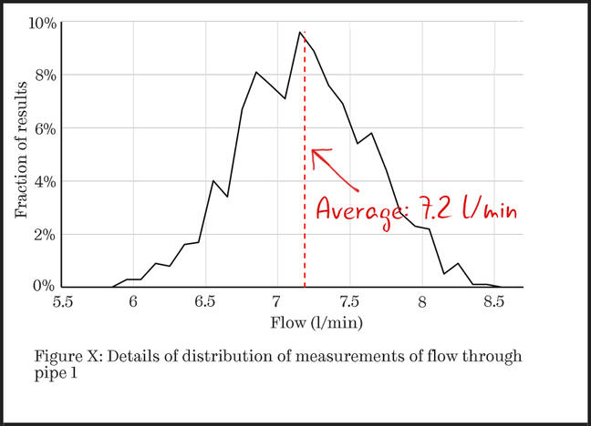 Figure 4: In this line chart, each point is at the centre of the bin.

### In summary…

If you want to illustrate a distribution of results:

* use a bar chart (histogram) if you have a small number of histogram bins
* use a scatter plot to show a cumulative distribution or to plot a histogram with a large number of bins

© The University of Sheffield

# Getting the most out of your graphs

[**25 comments**](https://www.futurelearn.com/courses/technical-report-writing-for-engineers/6/steps/595480/comments)

**When you enter your data into a processing package like Microsoft Word or Excel, the graph that you first get back may reflect your data, but may not always be the most clear or effective way to portray your results.**

In this video, we’ll show you how to customise a standard graph to communicate information more effectively.

This is not a tutorial on how to create a graph - these are our tips for getting the most out of your graph to make sure your message is clear.

We cover a lot of information in this video so don’t feel you have to take it all in at once. Remember you can pause and rewind whenever you need to. We have also provided a download of the key points that we cover in the video for you to take away.

Don’t forget to check out the ‘Downloads’ and ‘See Also’ section before you move on.

© The University of Sheffield

# How would you improve this graph?

[**73 comments**](https://www.futurelearn.com/courses/technical-report-writing-for-engineers/6/steps/595481/comments)

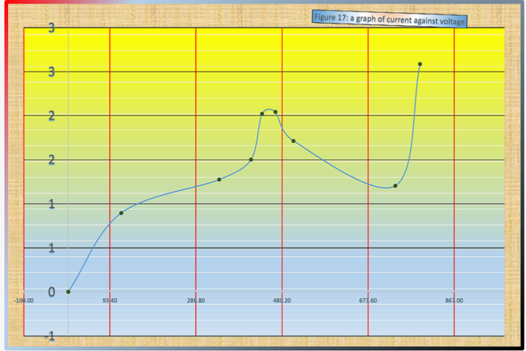

Take a look at the graph above. There are many, many, ways in which this graph can be improved. Can you identify what these are?

Comment with at least three suggestions in the discussion below.

© The University of Sheffield

# Displaying data in a table

[**45 comments**](https://www.futurelearn.com/courses/technical-report-writing-for-engineers/6/steps/595482/comments)

**Tables are a great way to display your data when the actual numbers in your results are important. Visually, they are not as attractive as figures or graphs, and the trends in your data may not be as obvious to the reader. However, if the reader wants to know the exact values you are reporting or if they want to use the data themselves, a table can be really valuable.**

Let’s look at some of the different circumstances where using a table would be appropriate.

### Reporting values

One place where a table can be effective is to report the values that you used.

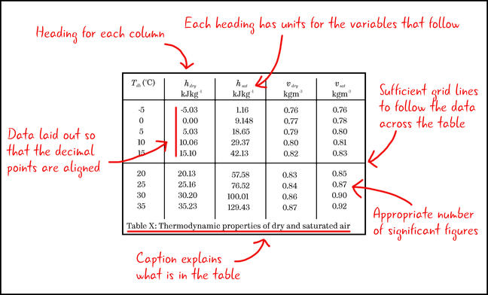 Table 1: An example of a table for displaying values used in an experiment.

This table demonstrates some best practice tips for presenting data in tables:

* There is a heading for each column.
* Each heading has the units for the variable that follows.
* There are sufficient grid lines to allow the reader to follow the data across the table, but not so many that each number is in its own box.
* The data is reported to an appropriate number of significant figures.
* Data is laid out so that the decimal points are aligned (this makes it easier for the reader to discern changes in the magnitude of values).
* A caption gives the reader information about what is in the table.

### Setting up information

Another place where tables are useful is if you have a series of different cases or parameters. You should show these in your report so the reader knows what you did and will be able to reproduce the work if necessary.

For example, the names defined in the table below can be used throughout the report to refer to the cases. This will allow the reader to see the differences between the different computer simulations that were run. In this case, they were 2 and 3-dimensional models and different leak sizes and positions.

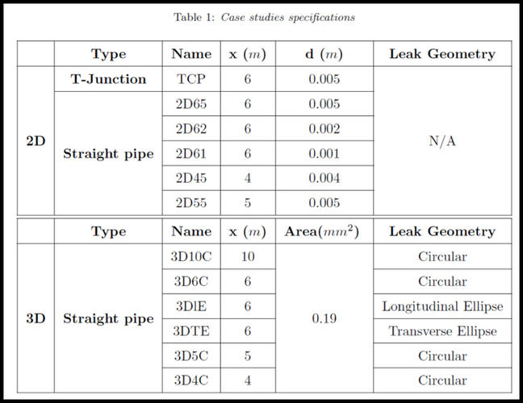

Table 2: An example of a table showing setup information.

Note that the table contains both numerical and non-numerical information. There are headers for the columns, which have the units in as required. Also, notice the careful use of grid lines to guide the user in what is unique and what is common between the models.

### Reporting non-numerical data

Tables are also useful for conveying results that do not have a numerical value.

For example, in the table below the results of an experiment have been processed and a decision made as to whether the output was stable (Yes/No).

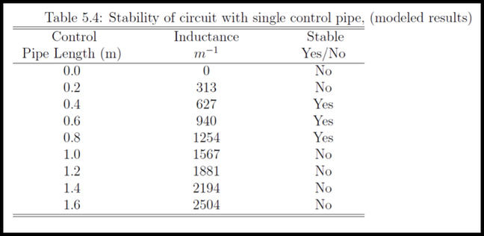  
Table 3: Processed numerical results showing non-numerical output.

The table is an excellent way to display this. There are two ways of defining the input (pipe length and inductance) and the output is a description (stable/unstable).

### Combining data

It is always useful to think about combining tables to save space. For example, the table above could have been two tables; one with length and inductance and the second with inductance and stability. By combining this data, there is no loss of information and the flow of the writing will not be impeded.

### Table tips

When you come to make a table for your report, ask yourself the following questions to make sure you are displaying your data most effectively.

* **Is a table the best way to display the data?**  
  Often a graph in the main body of a report and a table with the actual values in the appendix will be most effective.
* **How do you want to set the table out?**  
  Make sure the headings are clear and that units are included.
* **Have you labelled your table?**  
  Put a number and a title under the table so you can refer to it in the text. You can add “above” and “below” to the description, but this is not as useful as numbering tables. Some publications prefer the title to be above the table, so always check your house style.
* **Do you have many unnecessary decimal places?**  
  Report data to an appropriate number of significant figures and choose units so that your table does not include many zeros or unnecessary numbers.

For example, in the table below, the units chosen for distance and stress require multiple digits to correctly represent the values (such results can be reported by analysis software).

| **Distance (m)** | **Stress (Pa)** |
| --- | --- |
| 0.001 | 18541452 |
| 0.002 | 26756513 |
| 0.003 | 79629088 |

This table can be improved by choosing an appropriate unit for distance (mm instead of m) and by rounding the stress values to an appropriate number of decimal places (what this is will depend on your assessment of the errors in the values).

| **Distance (mm)** | **Stress (MPa)** |
| --- | --- |
| 1 | 18.5 |
| 2 | 26.8 |
| 3 | 79.6 |

### Discussion

Do you think tables are an effective way of displaying data. Can you think of an example where you have used a table effectively in a report?

### DOWNLOADS

You can download our ‘table tips’ from the bottom of the page. This will remind you how to display data effectively when you come to make a table for your report.

© The University of Sheffield

**Where have we been? Where are we going?**

[**45 comments**](https://www.futurelearn.com/courses/technical-report-writing-for-engineers/6/steps/595487/comments)

**This week, you have learned how to display the results of your work using text, graphs and tables.**

You have learned how to make effective graphs which are easy to interpret, how to display data clearly using tables and how to write text that describes your results so that the reader can appreciate what they have shown. You will also be aware of data, units and the effective use of significant figures.

The Results section is all about facts; from this section, the reader will now know what the work is, how you did it and what it produced. But they will not yet know what it means, how it fits into previous research or any of its limitations. This is what you will cover in the next section; the Discussion.

In your Discussion, you will put the work into context, discuss accuracy and limitations and use conjecture to try to explain your results.

Once you have done this, you can put the whole report together and also complete two short, but crucial sections, the conclusions and the abstract. These last two may be the only parts of your report that a busy reader or boss may actually read.

Next week, we’ll look at the Discussion and the Conclusion.

**Discussion**

How have you found this week of the course? Is there a key piece of advice that you will be taking away?

© The University of Sheffield

Week 5

# The Discussion and Conclusion

[**20 comments**](https://www.futurelearn.com/courses/technical-report-writing-for-engineers/6/steps/595488/comments)

**This week, we’re going to look at the final sections of your report; the Discussion and the Conclusion. These are sections which provide an effective ending to your report by answering the question “What do your results actually mean?”.**

The Discussion and Conclusion are two distinct sections, but writers sometimes struggle to separate the two.

* The **Discussion** is where you will explain the significance of your results in the context of your report, other work within the organisation and the wider literature on the topic.
* The **Conclusion** is a short review of what you have found from your experiment and will not contain any new information that has not already been introduced elsewhere in your report.

This week, we’ll look at each of these sections individually to make sure you understand which information goes where.

### What will the reader get out of the discussion section?

From the Discussion section, your reader will know what your results mean, how confident you are in them and whether there are any errors or uncertainties in your data.

They will also learn whether your results answer the questions you set out in your Introduction.

Finally, the reader will understand how your results are relevant to wider engineering problems and the potential impact your research has for real-world applications.

### What will the reader get out the conclusion section?

From your Conclusion, the reader should have a clear idea of what you found in your experiment and how this links back to your original aims and objectives.

If appropriate, they will also understand how your work could be built upon, applied or further validated.

### What skills will I learn this week?

This week we’ll focus on how to use language to communicate your results clearly and appropriately; considering who the audience is and what tone is suitable.

© The University of Sheffield

# What goes in a discussion?

[**25 comments**](https://www.futurelearn.com/courses/technical-report-writing-for-engineers/6/steps/595489/comments)

**The discussion is probably the least fixed section of your report. There are no hard and fast rules about what should go in and unlike the method and results, discussions don’t follow a particular format. However, it is important that your discussion has a logical structure and the argument has a clear flow to it. In this article, we’ll look at the key details that should go into a discussion section.**

The point of a discussion is to explain:

* What your results mean.
* Whether your results answer the questions or aims you set out in the Introduction.
* How your results are relevant to engineering problems.
* Where the sources of error were and how confident you are in your results.

### So what needs to be in your discussion?

* The discussion should **explicitly reference the aims and objectives** and address each one.
* The discussion section should **summarise the results**. It may seem obvious, but we often see technical reports where the discussions fail to mention the results.

**Example 1**: Significant differences were found between the two samples (p<0.005).

**Example 2**: The graph suggests a linear relationship between applied force and measured deflection.

This should include a discussion of **possible sources of error** in your results. The larger the errors, or the more variation in a range of results, the less confidence you can have in your results, and the less significance you can attach to them.

We usually talk in terms of “confidence intervals” within which a value is almost certain to lie, and “statistically significant differences” between two or more datasets we’re testing.

**Example**: I want to compare the mass of two samples, A and B. I take 10 measurements of each using the same method. Across the 10 samples, the average mass of sample A is 50g, and based on the spread of results, I am 95% certain that the real value lies between 45g and 55g. The average mass of B is 52g, and I am 95% certain that the real value lies between 48g and 56g. It is true to say that “the average measured mass of B was higher than A”. However, it would not be a true reflection of the data to say that “the results show that B is heavier than A”, because it is possible that B weighs 48g and A weighs 55g. The results show a difference in the measured values, but not a statistically significant one.

The discussion should attempt to **explain the significance of the results** in the context of the report, other work within the organisation and/or the wider literature on the topic.

It’s the only section where you can **use conjecture** (forming opinions based on incomplete information) for example:

* “The results suggest that…”
* “The differences between the two groups may be accounted for by…”
* “Errors may have been introduced by…”

**Example**: The nitrile gloves performed better than the latex. One possible explanation for this result could be the glove thickness.

But you shouldn’t make guesses without providing supporting evidence.

Your discussion might include comparisons with other work or reference to established theory.

**Example**: Neither test was able to find any significant difference between latex and nitrile examination gloves in their effect on roughness perception… It might be expected that the higher shear forces experienced with the latex gloves would affect perceived roughness. However, Taylor and Lederman showed, through both a theoretical model and experiments with grooved tiles, that friction is not a significant factor in perceived roughness.

You **should not** introduce any scientific theories or work (this should be done in the Introduction section) or any new data (this should be in the Results section).

Take a look at [this example Discussion](https://mooc-assets.shef.ac.uk/technical_reports/img/poor_discussion_example.pdf) from an experiment to measure the vibration properties of a beam under different conditions.

The writer has wrongly put all the theory here instead of in the Introduction, where it belongs. They have also failed to refer to their results!

A better example can be found in this excerpt from the same experiment:

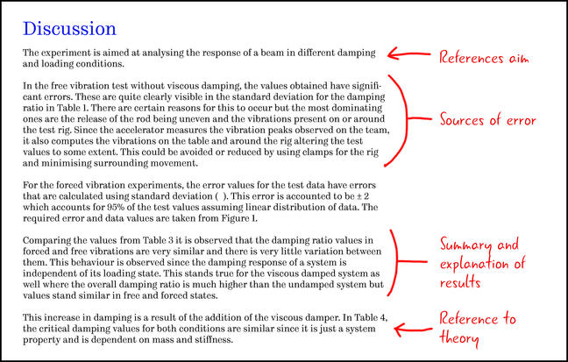

So now you hopefully have an idea of what should go into a discussion, and what definitely shouldn’t!

© The University of Sheffield

# How good is my data?

[**30 comments**](https://www.futurelearn.com/courses/technical-report-writing-for-engineers/6/steps/595490/comments)

**In your Discussion, you should explain how confident you are in your results by assessing the causes and impact of potential errors in the data. The term “error” does not necessarily indicate that you’ve done anything wrong. It is the difference between the measured value and the true value.**

It is impossible to measure any physical quantity with complete certainty. From random variations in the quantity being measured to limitations in the measuring equipment or the experimental method, there will always be errors in any measurement.

This means that if we measure some quantity and then repeat the measurement, we will almost certainly measure a different value the second time. By quantifying the possible spread of measurements, we can express uncertainty and say how confident we are about the result.

While the **error** is the difference between the measured value and the true value, the **uncertainty** is the range of values between which you are sure the true value exists.

It is common for the error in a measurement to be unknown. Consider using a ruler, with 1 mm divisions, to measure the length of a book. If the end of the book falls between two of the divisions of the ruler, you can’t determine the length exactly. However, you can be sure of a range of values between which it lies. This range is an example of uncertainty.

The uncertainty is an important part of your measurement as it allows the reader to place a degree of confidence in your results and to assess their significance in case of any discrepancy with earlier measurements or theoretical predictions.

It is important to remember that a large range of uncertainty in your data is not necessarily an indictment on your abilities. Uncertainties should be reported truthfully because as an engineer, you could be responsible for developing safety-critical systems.

The uncertainty should fully capture the reliability and range of potential values of the numbers you present so that systems can be designed to operate under the best and worst case scenarios. In this article, you’ll learn how to report the uncertainty in your data and how to express why this uncertainty is relevant to your results.

### Expressing the uncertainty in your data

A common notation adopted by engineers to report uncertainty is to write:

(value ± uncertainty) unit

For example:

(3.12 ± 0.03) m

Commonly, this would be considered the absolute limits of the range of possible values the true value could lie within. However, there are other ways that this notation could be interpreted by readers, particularly if they are familiar with statistics. It could be the scatter of your measurements, the standard distribution or the distribution of errors.

If you have detailed knowledge of the sizes of the errors associated with your readings then you may wish to let your reader know what these are. For general reports, it can be adequate to leave the meaning of the term after the ± vague. Best practice is to calculate the uncertainty as the **standard deviation** of the distribution of errors and to report that this is the uncertainty that is quoted.

### Standard deviation

When you have lots of repeat measurements of the same quantity, uncertainty can be expressed as a **standard deviation** of the distribution. The standard deviation provides a measure of the range of variability of individual measurements within the set that has been collected. If the standard deviation is small, it means all the values in the set are close to one another and if the standard deviation is large, all the measurements will be quite different from one another.

One standard deviation is defined as the range that contains 34.1% of individual measurements above the mean value and 34.1% of those below the mean.

**Example**: Let’s say we are measuring the speed of cars on a busy road. In an hour, we record the speed of 1000 cars. We could find the mean average speed of the cars by adding all the speed recorded and dividing by 1000. We then define a range containing 341 (34.1%) of the slowest cars travelling above the average speed. We also define a range of the fastest cars travelling below the average speed. The top minus bottom speed of cars in this range gives us the value of one standard distribution. Another way to think about it is ordering all the cars from slowest to fastest. Count 341 cars up from the average and find that speed. Count 341 cars down from the average and find that speed. The difference between the two is the standard deviation.

Another notation which is preferred in some technical work is to write:

3.12(3) m

This is the same value and uncertainty as before. A benefit of this notation, apart from being more compact, is that it is only used to report a standard deviation. The ± notation can sometimes be confused with the symbol for ‘fixed limits’ on an engineering drawing.

Whichever notation you adopt, make sure that your readers know what it means.

© The University of Sheffield

# In the lab: writing a discussion

[**21 comments**](https://www.futurelearn.com/courses/technical-report-writing-for-engineers/6/steps/595491/comments)

**So far this week, we have learned that a discussion is where you will explain what your results mean, their significance and how confident you are in them.**

Now let’s return to the lab to consider what information we would want to include in a discussion about our example experiment.

Once you have watched the video, download the example discussion from the bottom of the page to see how these ideas translate onto the page.

© The University of Sheffield

# Language, context and tone

[**28 comments**](https://www.futurelearn.com/courses/technical-report-writing-for-engineers/6/steps/595492/comments)

**Even with the most innovative research, if your discussion is not easy for the reader to understand, it will not have the impact it deserves. How you structure your discussion and the language that you use plays an important role in how well your findings are communicated.**

### Use subheadings

You should structure your discussion in a logical order. If this section is over three paragraphs, consider using subheadings to break up the text.

### Write concisely

Your writing should be concise but remain informative to the reader. Use complete sentences and paragraphs, but avoid long sentences where the key points you are trying to communicate could be missed. Instead, break long sentences into shorter ones or remove unnecessary words to make it easier for the reader to understand.

For example:

“In histology, tissue staining is the most important step, the reason is, most cells have no colour and their structure is difficult to observe under the microscope, so staining is used to give colour to tissues and highlight important cell structures.”

Can be effectively shortened to:

“In histology, tissue staining is used to highlight important cell structures and enable observation under the microscope as most cells have no colour.”

### Write impartial statements based on facts

As the purpose of a technical report is to communicate factual content, you should avoid using personal expressions, such as “I believe…” or “I think…”.

Your statements should be unbiased and based on facts, rather than personal opinion or feelings. To remain impartial and avoid making assumptions refer to the scientific literature when explaining your results and drawing conclusions.

For example:

“It can be speculated that the physical structure should be rough”.

If previous research studies have shown that the physical structure of this material is, in fact, rough, then state the findings of these research studies and cite their work in your text.

### Use a combination of tenses

In the methods section, you are expected to write using past tense as you are describing what you did. In the discussion and conclusion, you may use a combination of tenses.

For example, you may use:

* **Past tense** when referring to the experiment undertaken: “The experiment investigated the tensile strength of material A and B.”
* **Present tense** when making conclusions: “It is appropriate to investigate these two materials because…”
* **Future tense** when recommending how the experiment could be improved: “Recommendations for future work include repeating the experiment with different materials.”

### Use examples relevant to your field of work

As previously mentioned, all published sources of information should be cited in your text and listed in your reference section. Refer to your department handbook or academic supervisor for the preferred reference style.

### Proofread your work

Finally, check for spelling mistakes and grammatical errors before you submit your work. Check your sentences to make sure their meaning is clear. Read through your report and ask yourself “Are the findings of the investigation explained clearly, concisely and accurately?” If not, then edit where necessary. Ask a colleague, friend or family member to proofread your report.

© The University of Sheffield

# Be the marker: Discussion section

[**45 comments**](https://www.futurelearn.com/courses/technical-report-writing-for-engineers/6/steps/595493/comments)

**So far this week, we have learned what goes in a Discussion and the type of language and tone you should use when writing one. In this discussion, we’d want to put this (and previous) knowledge to the test.**

Below is an example Discussion section. We’d like you to read through this example and comment on the following:

* What is good about it?
* What is bad?
* How might the section be improved?

### Discussion

In this report, we are considering if the pipes that exist in our current distribution network should be repaired or replaced to reduce pumping cost. The relative roughness of a pipe is defined as the ratio of the pipe wall roughness and the pipe diameter. It becomes difficult to directly measure the roughness due to variation across the surface. In this experiment the relative roughness of the inside wall of a specimen pipe was determined through experimentation, by measuring the pressure drop for known flow rates of water. The relationship between pressure drop and average velocity of is given by:

Δp=ρfLDV22Δp=ρfLDV22

So, we can easily measure the geometrical properties of the pipe, the Length and the Diameter, and we know the density of water and the number 2. Therefore if the velocity and pressure drop can be measured on a sample of the pipe, the only remaining unknown in the equation is f, the friction factor. If we know the friction factor, and can use the velocity to determine the Reynolds number, we can determine the pipe relative roughness from the Colebrook equation [4]:

1f−−√=−2log(ϵ3.7D+2.51Ref−−√)1f=−2log(ϵ3.7D+2.51Ref)

A sample of the pipe was set up with pressure tappings at a known distance apart. Water was then pumped through the pipe and the flow rate, which can be used to determine the average velocity, was recorded using a weigh tank. The results show that at a Reynolds number of 10,000 the friction factor was 0.05 and at 50,000 it was 0.045. This indicates that the inner surface of the pipe has a relative roughness of around 0.015.

There could have been an error in calibrating the weigh tank and pressure readings could have been subject to parallax error. As already stated, we think the errors in the experiment are =+/- 3.

The significance of the findings relate the the increased use of energy required to pump the water in the distribution network using this roughness of pipe. Reducing the relative roughness of the pipe walls to 10-4, the friction factor could be reduced to approximately 0.03. It is estimated that that would reduce pumping power by approximately 30kW, which a potential cost saving of £26,280 per year. The estimated costs of repair and replacement of pipes to reduce the friction factor is 136,000, including downtime and installation. With a rigorous consideration of the uncertainties in the analysis, the payback period for the investment is between 4.5 and 5.8 years. It is therefore recommended that the current pipework remains in service.

© The University of Sheffield

# What goes in a conclusion?

[**26 comments**](https://www.futurelearn.com/courses/technical-report-writing-for-engineers/6/steps/595494/comments)

**The conclusion is a short review of what you have found from your experiment. It’s an opportunity to restate the aims or key questions and to summarise the key points raised in the results and discussion sections.**

A conclusion is different from an abstract or summary (which we will cover next week) because it does not summarise the whole experiment (aims, method, results, findings), merely the **findings and applications**.

It should be a series of brief statements. For example:

Sample A was found to have a significantly higher concentration of X than Sample B.

or

The results suggest a linear relationship between J and K. A very strong positive correlation was found (R = 0.95).

or

No statistically significant differences were found between the samples. Further study with a larger sample is recommended in order to determine whether differences exist between the populations.

It should cover both the findings of the experiment and its applications and should link back to the aims and objectives.

It can also contain proposals for future work, or these can be placed in a separate ‘Further Work’ section. For example, if the experiment found statistically significant results or trends, you might recommend applying the work to different samples or testing further variables; if differences were not found, refining the experiment or extending it to a larger sample.

The conclusions **should not contain any new information** – they are merely summarising things that have been covered in detail in the previous sections. For that reason, you should not enter into extended discussion or explanation in the conclusion. It should consist of brief sentences or bullet points.

### In summary:

* A conclusion is not an abstract – it should only cover the findings and applications of the experiment.
* A conclusion is not a discussion – it should be brief statements.
* A conclusion should summarise things already covered, not introduce new things.

© The University of Sheffield

# Where have we been? Where are we going?

[**40 comments**](https://www.futurelearn.com/courses/technical-report-writing-for-engineers/6/steps/595497/comments)

**On this course, you have been developing a toolkit of skills for producing professional, logical and detailed technical engineering reports. This week you have tackled the most important and, arguably, the most difficult section of a report: the Discussion.**

We have introduced some topics that you may want to consider including, such as how to discuss the errors and uncertainty in your results and what the significance of your work is on the wider world of engineering.

However, a Discussion section is highly dependent on the topic of work being reported and will vary significantly between different reports. To ensure this section is written well, the principal aspect to consider is that the meaning of the results, rather than a statement of the facts, is presented. It is here that your opinions and conjecture about the causes of the trends seen in the results can be included. Remember to clearly state that these are NOT facts but are carefully argued points arising from the literature and your own results.

We have also learned how to write a Conclusion and how it differs from the Discussion section. You now know that a Conclusion only contains things that you have shown to be true; it introduces no new material.

Next week, we’ll tackle our final section; the Abstract. This is a summary of the whole report which tells the reader the main points about the project.

In this final week, we’ll also teach you how to put all these individual sections together into a single, coherent report. We’ll explain the additional sections that are added onto the beginning or end of a report to provide the reader with the signposting necessary to find their way around your technical engineering report.

### Discussion

How have you found this week of the course? Do you think you are gaining confidence as a technical report writer?

© The University of Sheffield

Week 6

# Putting it all together

[**22 comments**](https://www.futurelearn.com/courses/technical-report-writing-for-engineers/6/steps/595498/comments)

**At the start of the course, we discussed how a report is made up of standard sections. As we’ve made our way through the course, we’ve learned the purpose of each section, as well as what goes in and just as importantly, what doesn’t go into each one. In our final week, we’ll learn how to put these sections together so that the document feels like a complete piece of work.**

### Writing an abstract

We’ll start with the important task of writing an abstract. This is a summary of the whole report which tells the reader the main points about the project.

Writing an abstract can be a difficult task. As educators, we often find that students struggle with this skill. We’ll share our tips for writing concisely and give you an opportunity to practice writing an abstract for yourself.

### Optional sections at the start and end of your report

We’ll then look at the optional sections which are added to the beginning or end of a report. This includes preparatory material for the reader at the start, which we call **front matter** and supplementary material at the end which provides additional details for the reader.

### Global formatting

We’ll also discuss how to ensure the document has a consistent appearance and how the structure can be clearly understood by the reader by considering the **global formatting**.

### Our final tips

To end the week, and the course, we’ll provide a selection of strategies for becoming more effective at writing reports, such as the best ways to get started and how to check for errors.

We’ll also share our **Report Writing Checklist** - a tool which you can use to write effective reports in the future.

© The University of Sheffield

# Reasons for putting it all together

[**18 comments**](https://www.futurelearn.com/courses/technical-report-writing-for-engineers/6/steps/595499/comments)

**In this animation, we revisit the central purpose of a technical engineering report and offer some final advice for writing a coherent and successful technical engineering report.**

© The University of Sheffield

# What is an abstract?

[**24 comments**](https://www.futurelearn.com/courses/technical-report-writing-for-engineers/6/steps/595500/comments)

**An Abstract is a summary of the whole technical report. It’s sometimes called the ‘Summary’ or the ‘Executive Summary’. It comes right at the beginning of a report, on its own page, and usually after the Title page. Because the Abstract is a summary of the whole report, it’s also the last thing you will write.**

### What’s an abstract for?

The Abstract tells the reader the main points about your technical project. Imagine the workplace - if someone is very busy, they may not have time to read the full report. They may also not have a technical background. The Abstract gives them an overview and can help them decide which specific sections to focus on. Plus, if the reader is looking for particular information, the Abstract tells them if the report includes that information or not.

Finally, if the reader is faced with a pile of reports, the Abstract helps them decide which ones to read.

This all saves the reader both time and effort.

### Writing concisely

Effective Abstracts are concise, i.e. they should not include any unnecessary words. If you write a clear and informative Abstract, your report is more likely to be read. This is good for you, as your work will become known.

It’s actually quite difficult to write concisely - people who are new to the task often find it a challenge to distill their entire report into a few sentences. With practice, though, you can develop this skill.

### So how do I write an Abstract?

Your abstract should answer the following key questions:

* Why?
* How?
* So what?

This means you should focus on:

* The Problem (Why?)
* The Solution (How?)
* The Impact (So what?)

### What should I include?

The Abstract should only include the ‘headlines’ of your report, i.e. key information about the following:

1. Background of your project (why you did it / why the project was necessary)
2. Aim(s) of your experiment/research/project (what you were specifically trying to do)
3. What you actually did (your procedure or experimental method)
4. What you found (your results)
5. What your results mean (your conclusion)
6. Any recommendations and/or special considerations for the future (implications)
7. Any limits to how far your conclusions can be applied (limitations)

Abstracts often follow this order as it is the same order as the information in the main report.

‘Key’ information means the most important information. Depending on your project, ‘implications’ and ‘limitations’ may be optional. Your decision to include or exclude them depends on how important you think they are.

The Abstract should be self-contained, i.e. can be read and understood without needing to refer to other documents.

The Abstract should not include:

* Graphs or tables
* Pictures or equations
* Abbreviations, acronyms or jargon

### How do I summarise my key information?

You can use questions to help you summarise each section of your report.

Imagine someone wants to know about your project and asks you questions about it.

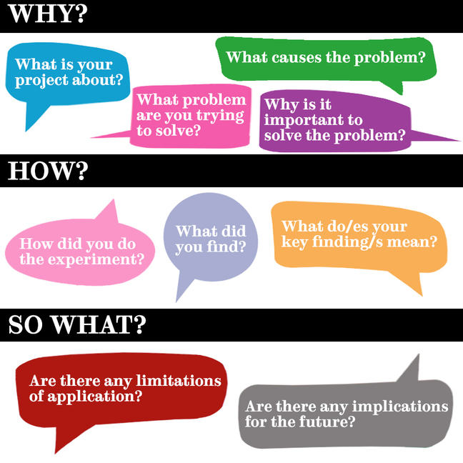

Some examples of guiding questions

Answer each question aloud in one sentence - keep it simple! Once you have answered the question aloud, write your answer down (or type it in!).

Then, join your answers together into two or three sentences to create paragraphs.

### How many paragraphs should I write?

Different companies and organisations can have different preferences but two or three paragraphs is common.

* **Paragraph 1: Why?** Join your answers to Questions 1-4 into a couple of sentences so they make sense.
* **Paragraph 2: How?** Join your answers to Questions 5-7 into two or three sentences so they make sense.
* **Paragraph 3: So what?** Join your answers to Questions 8 & 9 into a sentence so they make sense.

© The University of Sheffield

# Why do you need an abstract?

[**26 comments**](https://www.futurelearn.com/courses/technical-report-writing-for-engineers/6/steps/595501/comments)

**For many, the abstract or executive summary is the most useful part of a technical report.**

In this video, our expert engineers explain why this section is important and give their tips for writing an effective abstract.

© University of Sheffield

# Front matter

[**24 comments**](https://www.futurelearn.com/courses/technical-report-writing-for-engineers/6/steps/595505/comments)

**At the start of a technical engineering report, there is a usually a certain amount of preliminary material before you get to the detailed content.**

This ‘front matter’ should always include an abstract, but other items you could consider are:

* Title page
* Foreword, quotation or acknowledgments
* Contents page
* Lists of tables, figures or equations
* Nomenclature section

The type and amount of material at the start of the report should be based on what is appropriate for the document. For example, it would be unnecessary to have a contents page for a three-page document and there is little point in having a list of tables if the report only contains one table.

Always check the requirements of the report with the person or organisation you are producing the report for.

## Title page

 An example of a title page for a PhD thesis following the institutional standards of the University of Sheffield.

### Design

The title page provides a cover to the document and creates a first impression of the content. Therefore, the design should be simple, clean and functional, demonstrating to the reader that the document is there to do a job.

### Title

The title will be the most prominent item on the title page. It should summarise the subject matter and the results of the work without being too off putting or using unnecessarily complex language.

Some examples of good titles are:

* “An experiment to determine the coefficient of friction between a variety of surfaces”
* “Validation of the principles of conservation of energy”

### Author name

The author’s name and any contributors to the report should appear.

### Date

If it is a short report, written in a few days or less, the exact date the document was finalised would be included, with a day, month and year. If the report took a more substantial amount of time to complete, then putting the month and year, or just year, of publication, may be more appropriate.

### Miscellaneous

The rest of the items will depend on who the report is for. For example, if the report is for a particular company, they may have a house style which conforms to their corporate branding. This might include details such as the company logo or business address.

If the report is being submitted as part of a University coursework assessment, and no guidance is provided about what should or shouldn’t be included on the title page, consider including details such as academic department, student ID number, supervisor…etc.

## Foreword, quotation or acknowledgments

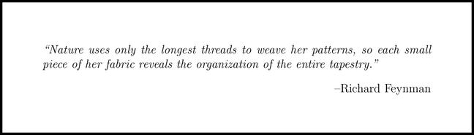 An example quotation from a technical engineering report.

### Foreword

Particularly long documents may open with a “foreword” after the title page but before the abstract. The foreword provides an external perspective on the context of the work and it’s value to the wider world. It’s usually written by someone who is recognised in the field of study to endorse the work contained within the report.

Forewords are often written in an informal tone and can provide an opportunity to stamp a little personality on the precision of what is to follow.

### Quotation

Likewise, a well-known quotation can be used instead of or as well as a foreword to personalise the start of larger documents. A quotation should reflect the personality of the author and be related to the work in the report (even if only tenuously). If you are including a quotation ensure that it is correctly attributed. This section does not need a section header.

### Acknowledgments

Whether working as an engineer in industry or as a student in a first-year lab, you will be supported by staff that are not contributors to your work but without whom you wouldn’t have been able to deliver the project.

This could be someone providing administrative support, a senior person from whom you have sought advice or a technician that helped set up or fabricate your equipment. It could be that a person or organisation has provided you with the funding required to deliver your project. The acknowledgement section provides a polite and professional way to say thank you for their contribution.

## Contents page

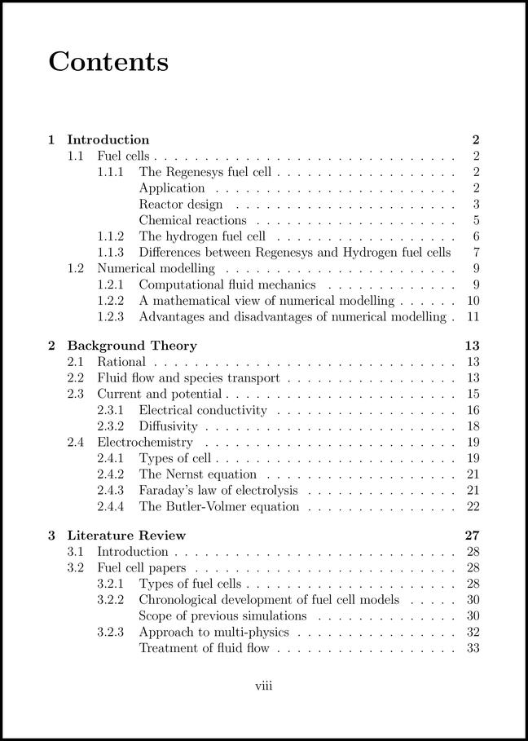 An example contents page from a technical engineering report.

A contents page performs two main jobs:

1. Provides a list of all of the sections and subsections used to break up and structure the report.
2. Allows readers to quickly navigate to specific parts of the report.

Remember to give a page number for each item. This way the reader can skip directly to the part of the report they are interested in. A common error when producing a contents page is to list the sections and subsections but fail to provide the page numbers.

When writing the list of items for the contents page, it’s important to include both the names and the numbers of the sections and subsections. We’ll talk about this in more detail when we look at “global formatting”.

## Lists of tables, figures or equations

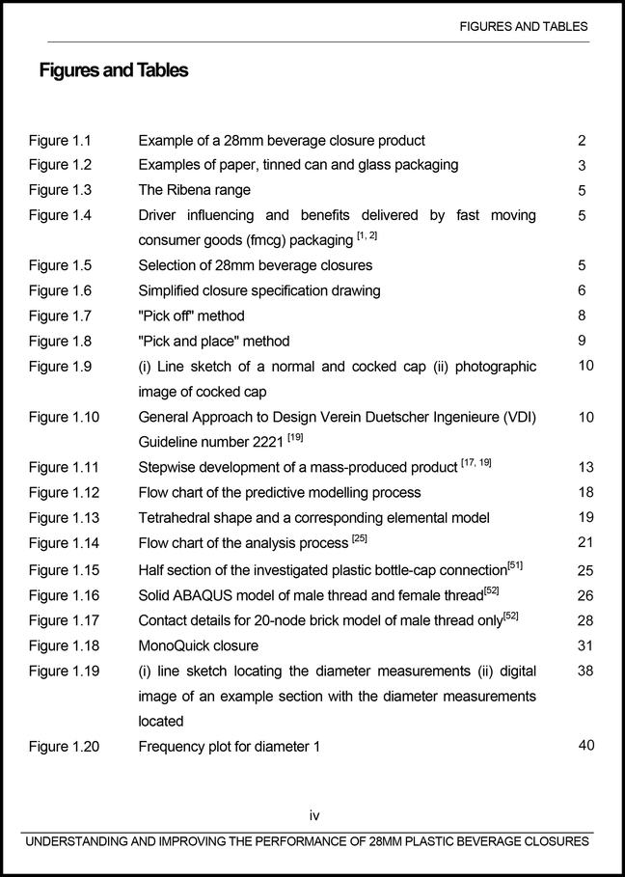 A list of figures from a technical engineering report.

Large reports tend to include lots of tables, figures or equations. Listing them at the beginning of the report enables the reader (and the author) to quickly jump to the appropriate point in the document, just like a contents page.

It’s important to include the name of the figure, table or equation; their number and the page number where they can be found. For figures and tables, this name should match the caption underneath.

You can automatically generate lists and content pages using software such as Microsoft Word or LaTeX. To do this, you must ensure you set up the items, such as section headings and figure captions, correctly. When you do, the software ensures the items in your lists and the contents page are dynamically linked and will update as the document is changed. This can save a great deal of time.

## Nomenclature section

 An example nomenclature section from a technical engineering report.

All the symbols, or nomenclature, used to represent physical properties need to be defined for the reader at some point in the document. You can either define the nomenclature specifically for that equation directly after it is embedded into the text or define all the nomenclature for all the equations in a dedicated section in the front matter of the report.

This second option is preferable when there are lots of equation in the report and the same symbol is referred to in multiple equations.

As the writer, you may also find it helpful to create a nomenclature section to keep all the symbols in a single place. This way you can check that every symbol you use has been defined and that the same symbol is consistently used for the properties.

The nomenclature section is a list of the symbols used in the report followed by a definition. Symbol lists should be separated into Latin and Greek (and any others that you may be including) and listed in alphabetical order Latin (A - Z), Greek (α - Ω).

Remember, upper and lower case of the same letter can be defined as two different properties.

A third column, containing the unit where appropriate, can be included if it is useful for the reader.

## Which sections should I include?

There are no hard and fast rules about which of these front matter sections should or should not be included, or in which order. When deciding what to include, consider how useful they will be for the reader.

As always, consider who the report is for, how long and detailed it is, and what it will be used for.

Unless there are good reasons to do otherwise, your front matter sections can appear in the order listed in the bullet points above.

© The University of Sheffield

# Appendices

[**20 comments**](https://www.futurelearn.com/courses/technical-report-writing-for-engineers/6/steps/595506/comments)

**Any material that isn’t necessary to the body of the work, but which you think the reader may want access to, can be put into an appendix. You can have as many appendices as you need to contain all the supplementary information you wish to include.**

These are usually differentiated with numbers, letters or roman numerals, for example:

“The standard operating procedure for the MCX23 Hyperdrive can be found in Appendix C”

or

“Details of the mathematical process are located in Appendix III”

As an author of technical engineering reports, you are constantly striving to find a balance between including enough detail, so that the information can be understood and scrutinised, and maintaining focus, with concise writing and elimination of superfluous content.

The appendices can be used to overcome this seemly intractable tension. If you are unsure if details need to be included, then they probably don’t, but you can put them in an appendix to make sure.

Here are some common uses for appendices in technical engineering reports:

* **Equipment details**: The reader of a report should be able to replicate your work to validate that your results are correct. If you are using a particular piece of equipment, details such as the model number, the calibration or the setup procedure might not be relevant to the concepts in the main body of the report, but would be necessary to replicate the work.
* **Raw data**: When you do experiments, you often collect a great deal of raw data. The raw data is then processed and presented in a way that demonstrates a point or concept to the reader in the Results section. Including the raw data in an appendix allows the reader to validate that the processing has been done correctly and perhaps interpret the data differently with a different processing method.
* **Processing**: The steps used, possibly mathematical ones, to take raw data might be complex and the complexity not directly relevant to the reader. For the purposes of validation, the methods used to process data into results could also be included in an appendix.

© The University of Sheffield

# Making it manageable

[**18 comments**](https://www.futurelearn.com/courses/technical-report-writing-for-engineers/6/steps/595507/comments)

**A technical engineering report is quite often densely packed with detailed information. Even when broken down into standard sections, such as the introduction or results, they can still remain unhelpfully large and unwieldy for the reader to get to grips with. In this article, we’ll explain how you can structure your report to make the material manageable and digestible.**

### Use subsections

It is quite common in technical reports to break down the content of the standard sections into **subsections**.

For example, if your project involves renewable energy generation, and your reader requires extensive background knowledge of current technologies, it may be appropriate within the introduction to create subsections for wind power, hydroelectric and solar etc.

If within these subsections there are still chunks of content, then each subsection can be further broken down, into subsubsections. This process can continue, so subsubsections can be broken down into subsubsubsections and so forth.

Each subsection should contain a single, digestible idea. A good rule of thumb is that if you can think of a title to describe a chunk of the text, then this can be placed into its own subsection.

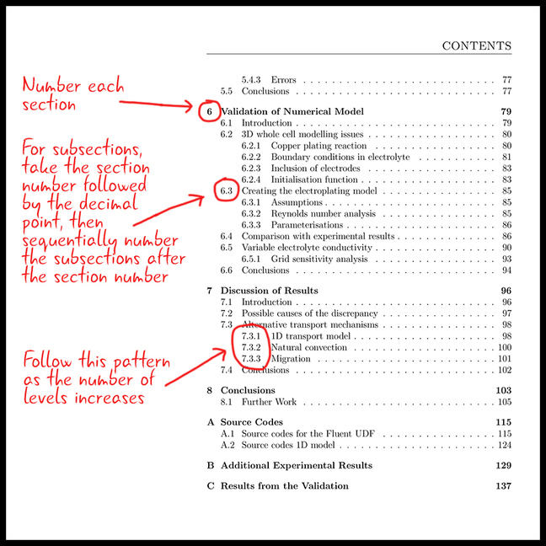 Figure 1: A contents page of report which has been broken into sections, subsections and subsubsections

You will decide how many levels to use based on the most effective way to communicate the material in the report.

Not all parts of the document need to be broken down to the same level. For example, the Introduction may have no subsections at all whilst the Results section has subsubsubsections. It’s all dependant on the material that is presented and how it can be organised best.

### Number your sections

Every level of the section, subsection and beyond, must have a title and be sequentially numbered.

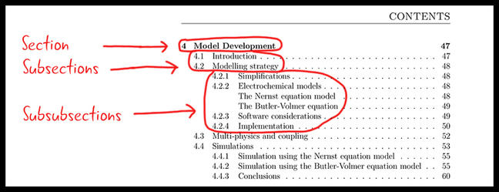 Figure 2: How to number your report

Generally, sections that appear in the front matter, such as abstracts, forewords and nomenclature, will not have section numbers but can appear in the contents page.

### Add page numbers

A page number should appear on every page in the document [1]. These should be sequentially numbered and referred to from the contents page and, if one is included, the index.

Page numbers are very useful for two reasons:

1. **For reference**. If you need to refer to a particular part of the document, either in conversation or as a cross-reference in the text, then using page numbers can be quite effective.
2. **For when things go wrong**. Imagine you have just printed your 200-page technical engineering report five minutes before a big deadline. As you are delivering the document to your boss for review, you slip and the papers fly into the air. How are you going to sort them back into the correct order? If each page is numbered, this turns from a painstaking to a fairly trivial task.

For large documents, that contain several pages of front matter, it is common to number the pages that contain the front matter with lowercase roman numerals (i, ii, iii, iv) and to begin numbering at the first section that contains the content of the report.

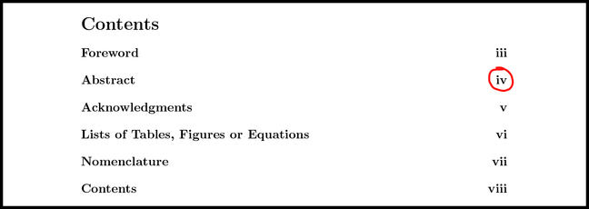

### Structuring from the start

When writing a technical engineering report, it can be helpful to start with the basic report structure. This provides a good outline or framework for the content that you wish to include and ensures you say everything you want within a logical narrative.

You can then start to fill in the content for each of these sections and subsections in any order, with the knowledge of how what you are writing relates to the remainder of the report.

You can download an example of a report structured with section and subsection numbers and a contents page below.

© The University of Sheffield

# Looking professional

[**39 comments**](https://www.futurelearn.com/courses/technical-report-writing-for-engineers/6/steps/595508/comments)

**Throughout this course, you have been introduced to the standard elements of a technical engineering report. These are elements such as figure numbers, section headings and references. When you start to use these elements, you need to decide on a style of typesetting for each element - and apply it consistently throughout your report.**

When we talk about typesetting, we are referring to aspects of the presentation such as the typeface, the font size, the indentation, the alignment on the page or any attribute that dictates how the element appears.

In a technical engineering report, there should be distinct typesetting for each type item and it should be applied consistently for every instance of the same type of item.

For example, if a figure caption is set to bold, 11pt centre aligned, this should be different from the body text and applied to every figure caption in the report.

The items that will need a specific typesetting include:

* Section, subsection and below numbers and headers
* References and citations
* Figure and table numbers and captions
* Equations numbers
* Body text
* Footnotes
* Page numbers
* Body text
* Technical terms in the body text
* Emphasis in the body text
* Page margins

There are two reasons why engineers do this:

1. The reader needs to know what type of item they are reading. For example, if a subsection header looks the same as the body text or looks different to all the other subsection headers, the reader won’t easily understand that it is a subsection header.
2. Inconsistent typesetting produces a messy, poorly presented report that reflects badly on the author.

Problems of consistency often occur when several authors work on the same report or when one author doesn’t pay attention to setting up a consistent set of styles.

The key to avoiding mess is to identify the different layout elements that have been created within the document and check for consistency. Once the document is finished, run through the whole report, identify when each of these elements occur and ensure the font, typeface, size, alignment…etc is distinctive and has been applied consistently.

While the typesetting should make the text of each of the report items distinctive so they can be identified from the body text, avoid using too many different sizes and fonts. This can make the document look a little childish.

### Discussion

Why do you think global formatting is important?

© The University of Sheffield

# Be the marker: Spot the mistakes

[**31 comments**](https://www.futurelearn.com/courses/technical-report-writing-for-engineers/6/steps/595509/comments)

**Throughout this course, we have been sharing the common mistakes that we frequently see when marking technical engineering reports.**

In this step, you’ll have the opportunity to walk in our shoes and have a go at marking a technical engineering report.

**How many mistakes will you find?**

Download the report from the bottom of this page and see how many mistakes you can spot. We’ll ask you to share your answers on the next step - so no peeking!

© The University of Sheffield

# Did you spot these mistakes?

[**21 comments**](https://www.futurelearn.com/courses/technical-report-writing-for-engineers/6/steps/595510/comments)

**In the previous step, you were asked to download an example of a report that contained lots of deliberate errors.**

How many did you spot? In this section, we highlight some of the biggest mistakes the writer of this technical report has made.

### Page 1

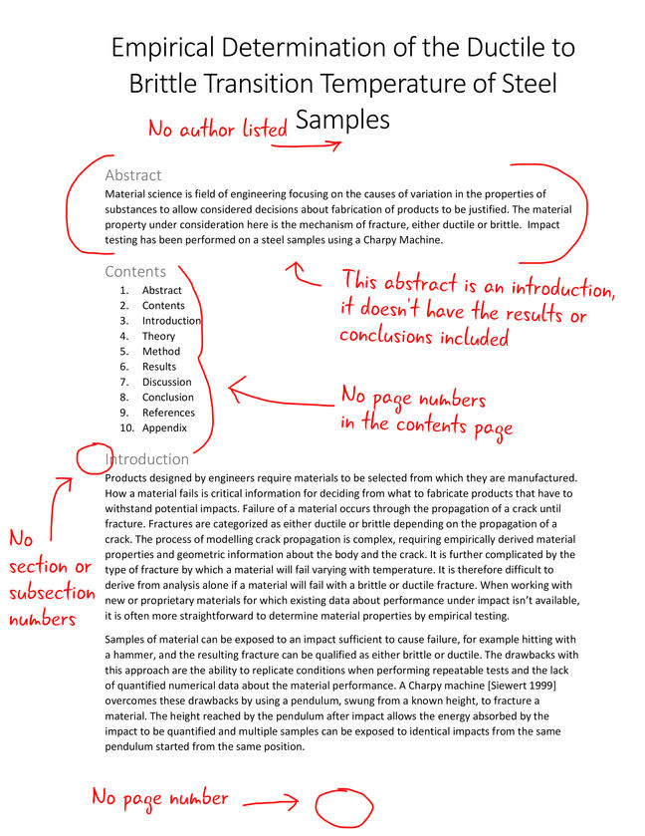

### Page 2

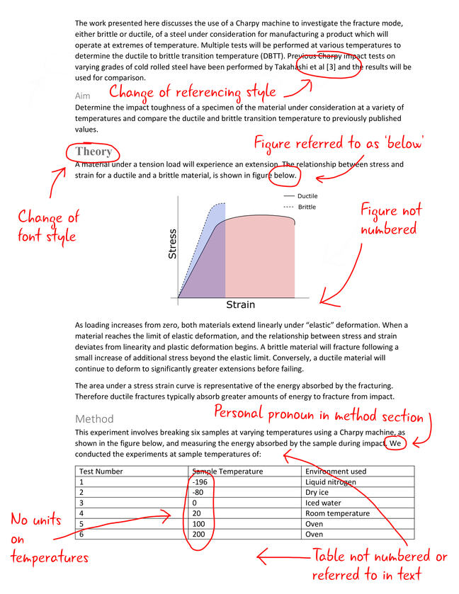

### Page 3

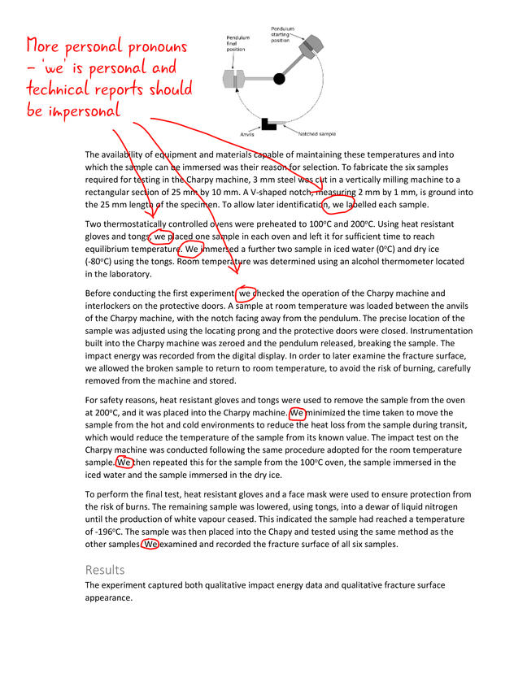

When an experienced marker views a document containing these types of errors, they spot them almost immediately like it is second nature. Have you, after learning on this course, developed this skill?

© The University of Sheffield

# Be an effective report writer

[**21 comments**](https://www.futurelearn.com/courses/technical-report-writing-for-engineers/6/steps/595511/comments)

**As we near the end of the course, we asked our educators to share their advice for becoming an effective report writer. In this step, they share tips that could save you lots of time and improve the quality of your output.**

### “Start with the structure”

Sometimes, the biggest barrier to writing a report can be getting started. One approach that can help you to get going is to first set out the structure. Work out the sections, subsections etc. and write bullet points for what you want to say, without too much concern for spelling or precision in language.

Once you have the document planned out, you can replace the bullet points with formally written prose, using the high-quality and concise language expected in a technical engineering report.

### “Use the tools”

Most document creation software (such as MS Word) will have built-in tools to automate the global formatting, such as numbering section headings, figures and equations and setting up referencing and citations. It can take a bit of time to set this up, but once you have mastered this skill, it can make your life much easier.

Consider having numbered the 30 equations in your document manually, and you decide to add another one in between number 1 and 2. You now need to renumber every equation from 2 to 30. If setup correctly in the software, you can insert a new equation and it will automatically number it and change the numbering of all equations in the document to be correct.

### “Consider using other tools”

Whilst programmes like MS Word and Excel are ubiquitous in University and Industry, there are other software tools that have a particular advantage for producing technical engineering reports.

One example is LaTeX. It has a very steep learning curve and is in no way user-friendly, but, once learned, it can make the process of producing documents very straightforward. It is favoured by mathematicians and physicists who tend to include a great deal of mathematical content in their work.

### “Let it mature”

A technical engineering report can be like a fine wine. Not only can writing one give you a headache but it can benefit from being left to rest for some time.

Once you have finished writing your report, the contents will be fresh in your mind and it can be difficult to read your work in the same way that another reader would.

One way to overcome this problem is to give yourself some time between finishing your report and submitting it. When you come to review the report again, you may spot mistakes and see improvements that you might have missed previously.

### “Know when enough is enough”

It is tempting to fiddle with a report, the appearance, the wording, the language etc. until it is perfect. However, when a deadline is pressing and your time is important, knowing the difference between a report that is “good” and one that is “good enough” is important. One of the traits that define a good engineer is the ability to assess the relative importance of projects and attribute appropriate resources.

### “Get others involved”

Proofreading your own work is always hard. You tend to read what you think you have written rather than what is actually on the page. If you can get other people to proofread your work, this is usually better than doing it yourself.

If you have access to technically trained people that are experienced in writing reports, their input can be invaluable, but anyone can offer constructive feedback from the perspective of a reader. And it never hurts to make friends with your local resident pedant.

### “Save your work”

Even in this day and age, computer files, and the time and effort used to create them, still get lost due to technical issues such as crashes and malfunctions. Save work regularly, make back-ups on another device (upload to the cloud or a memory stick) and save updated versions with updated filenames.

Usually, people have at least one catastrophic loss of work in their life before they learn the importance of good habits in creating backups and archiving their work.

© The University of Sheffield

# The future of report writing

[**31 comments**](https://www.futurelearn.com/courses/technical-report-writing-for-engineers/6/steps/595512/comments)

**At the start of the course,**[**we heard from Professor Mike Hounslow**](https://www.futurelearn.com/courses/technical-report-writing-for-engineers/6/steps/595435)**who described how he wrote his first technical reports in biro on a pad of paper. Although technology has changed over the years, Mike explained that the conventions he used have remained constant throughout his career.**

In the final discussion of the course, we’d like to hear what you’re going to take away from this course.

Thinking back over the advice that you have heard about writing technical engineering reports, which bits do you think will remain the same, and what do you think will change in the future as technology and society develop?

© The University of Sheffield

# Your Report Writing Checklist

[**32 comments**](https://www.futurelearn.com/courses/technical-report-writing-for-engineers/6/steps/595513/comments)

**We have reached the end of Week 6. Congratulations on finishing the course and thank you for participating with us. As a reward for all your hard work, we’d like to share our Report Writing Checklist.**

The Report Writing Checklist is a tool which will help you remember and apply what you have learned on this course when you come to write your next report.

Run through the checklist before you submit your work and ensure you haven’t missed anything out and get the credit you deserve.

Check under ‘DOWNLOADS’ at the bottom of the page.

We hope that you have gained some skills that will benefit you during your career or studies. It just remains for us to wish you all the very best in your future endeavours and to thank you again for taking part in Technical Report Writing For Engineers.

If you have enjoyed the course, please do [leave us a review on Class Central](https://www.class-central.com/review/new/9087). This helps new learners to discover the course and find out whether it’s right for them.

© The University of Sheffield